Burghy-Versi
GAME PLAY Manual

Project Manager – Erik Meissner

Design – Christopher Russo

Developer – Jim Tyndall

Developer: Chad Morse

Documentation: TammyAnn Baker

Testing: Dane Davis

Revision: 1

About this Document
This document contains the basic information for playing Burghy-Versi, by showing step-by-step
actions.
On the start of game at top you will see black: 2 and white: 2. That is the score and it will
Change as moves are made. The bottom of screen will have a box around black or white
Whomever is the current turn is on.
About this Document 2
Revision History Error! Bookmark not defined.
Introduction Error! Bookmark not defined.
Introduction and Purpose Error! Bookmark not defined.
Project References Error! Bookmark not defined.
Glossary Error! Bookmark not defined.
SYSTEM OVERVIEW Error! Bookmark not defined.
System Application Error! Bookmark not defined.
System Organization Error! Bookmark not defined.
Information Inventory Error! Bookmark not defined.
Resource Inventory Error! Bookmark not defined.
Report Inventory Error! Bookmark not defined.
Processing Overview Error! Bookmark not defined.
Communications Overview Error! Bookmark not defined.
Security Error! Bookmark not defined.
SITE PROFILE(S) Error! Bookmark not defined.
Site Location(s) Error! Bookmark not defined.
Primary Site Error! Bookmark not defined.

Installing the game

- Download under Othello off Bitbucket 4.17.13 Release.zip.

- Download Microsoft xna version .net 4.0. Make sure computer has .net 4.0.

- Extract files.

- Then you can play the game.

Opening the game

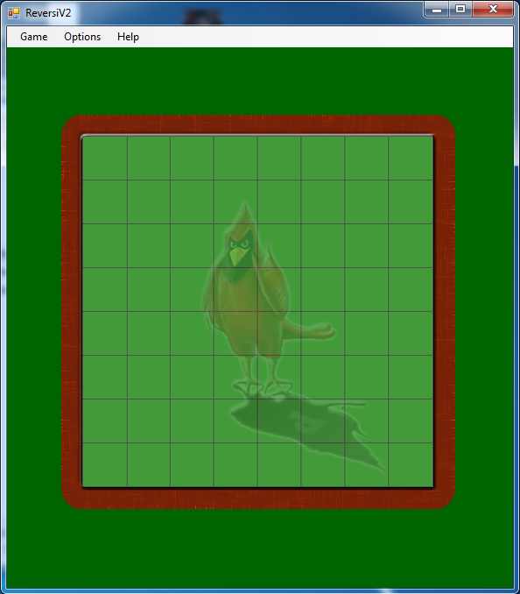
This is the screen you will see.

starting a new game

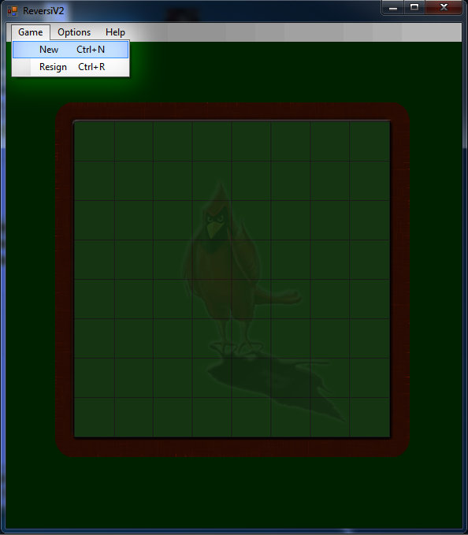
Before this you may want to set players under options and pick colors. You can also set plays to computer or player.
Select new to start game.

Resigning a game
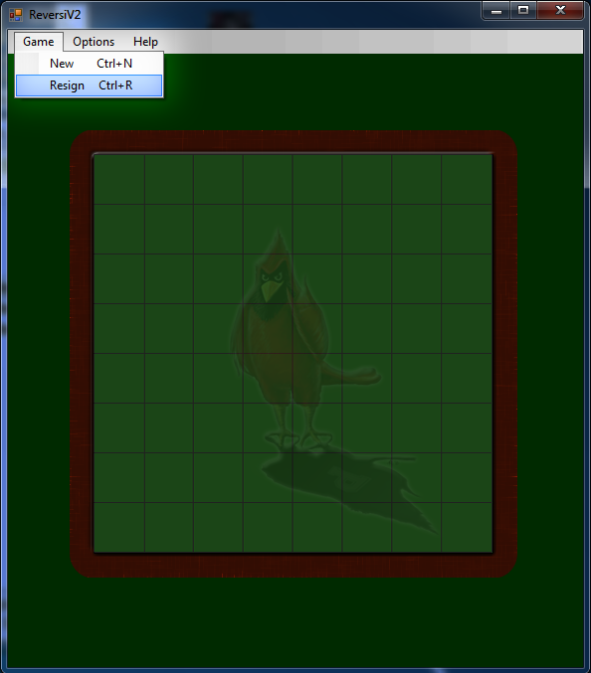
To quit game click resign with mouse or do command.

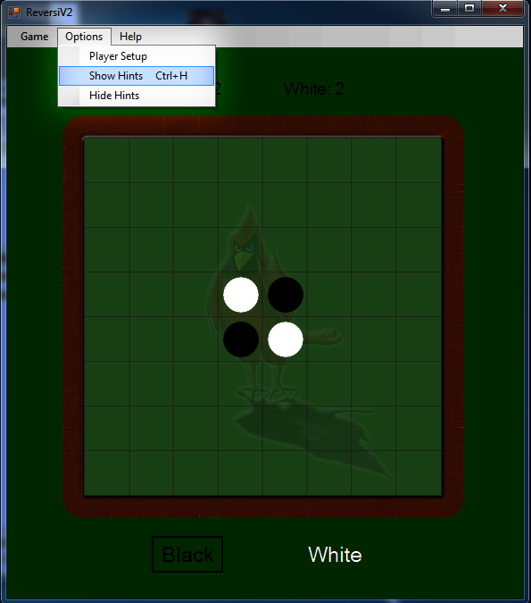
Showing hints
Hints are shadowed and you can pick the best one that you think (use strategies under help) then select move.
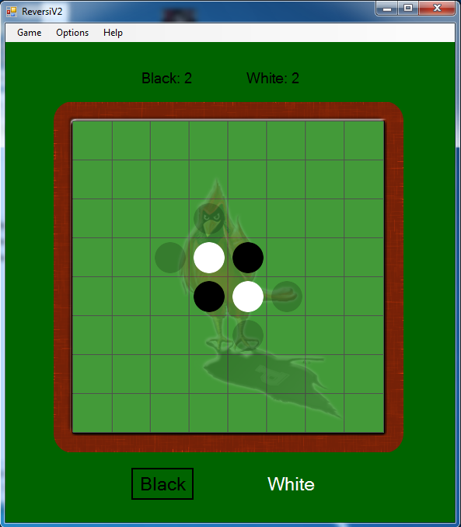

making a move
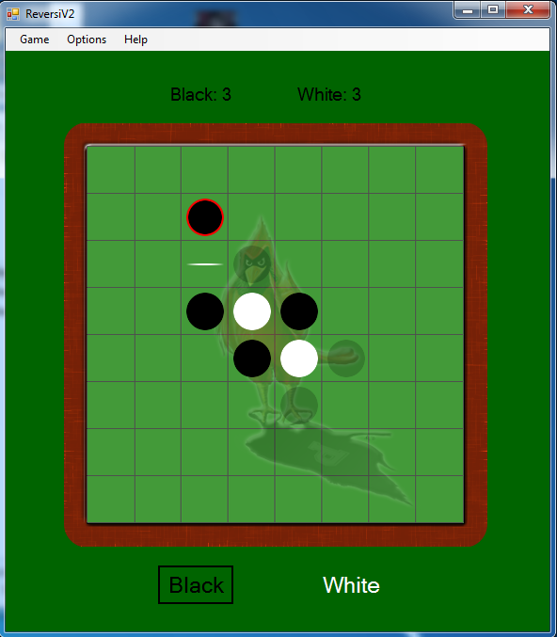
Use hints shadowed circles and strategies to help make move and select.

