Achievement
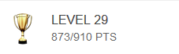

Achievement display board
As a user I need an achievement display board to view my achievements progress level in terms of points and level in order to motivate myself to keep finishing the daily goals.
Acceptance Criteria:
- The display board should be on top of page
- The start level should be level 1
- The achievement should be unlocked once the requirement is satisfied
- Only daily achievement can be completed more than once(i.e. can be completed every day)
- A notice board will be poped up when an achievement is unlocked
Definition of Done:
- Pass final acceptance test
- Approved by UI team

Functionality:
Achievements should be unlocked immediately once the requirements are satisfied, score and level should be calculated and updated correctly.

When the achievement is locked, a “locked” picture should be displayed beside to the corresponding achievement.. If the achievement is locked, a “completed” picture should be displayed beside to the corresponding achievement.

Before unlock the achievement

After unlock the achievement:
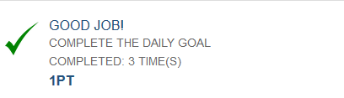

Daily goal can be completed every day, the achievement should be reset to “locked” in a new day.

When an achievement is unlocked, the pop up notice board should show the corresponding unlocked achievement.

