25/11/2013 Object Variables – Osian Clifford
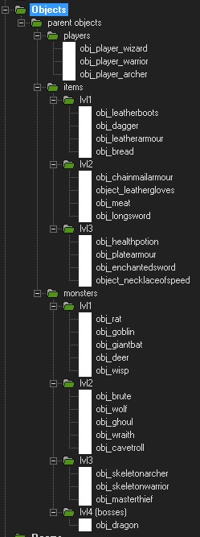
25/11/2013 - I create the parent objects of the basic objects that will be used in the game. This includes the player choices of Warrior, the Archer and the Wizard. I created basic monsters in different levels; level 1, 2 and 3 with four different object instances for each level hierarchy. I also added one basic boos at the end for a type of goal to achieve. I also created basic parent objects that the player can use throughout the game and the battles with the monsters which are also split up in their own level hierarchy system. (See image below) This is basic right now but can be improved later as we polish the game but right now we need a basic running version of the game to run.
As the monsters and the objects increase in level so do their powers and effects. For example a level one rat is weaker than a level two wolf or a cave troll and they are weaker than a level 3 skeleton warrior or archer etc.
As same with the monsters, the objects give more benefits than the previous level, such as a level 3 health potion is stronger and better than a level 2 meat which is stronger than a level 1 bread etc.
Each class the player can choose form has different attributes assigned to them as variables so at the start of the game each class has set attributes which are different form each other, all 3 classes have strengths and weaknesses which give the player some choice on how they choose to play the game and such. (see image on next page)
Each class has a variable stating their strength, defence and agility.
Strength – is used for attack power in battles against monsters. The more strength a player has, the more damage they will do to the enemy in a battle.
Defence – is used to negate damage form an enemy monster. The more defence a player has, more damage they can negate and repel from the enemy in a battle.
Agility – is used to determine who attacks first in a battle and how many times they can attack. The more agility a player or monster has, the more they can fill their “turn” bar in battle which leads onto multiple choices which they can then choose form a menu what they wish to do (explained more on next page)
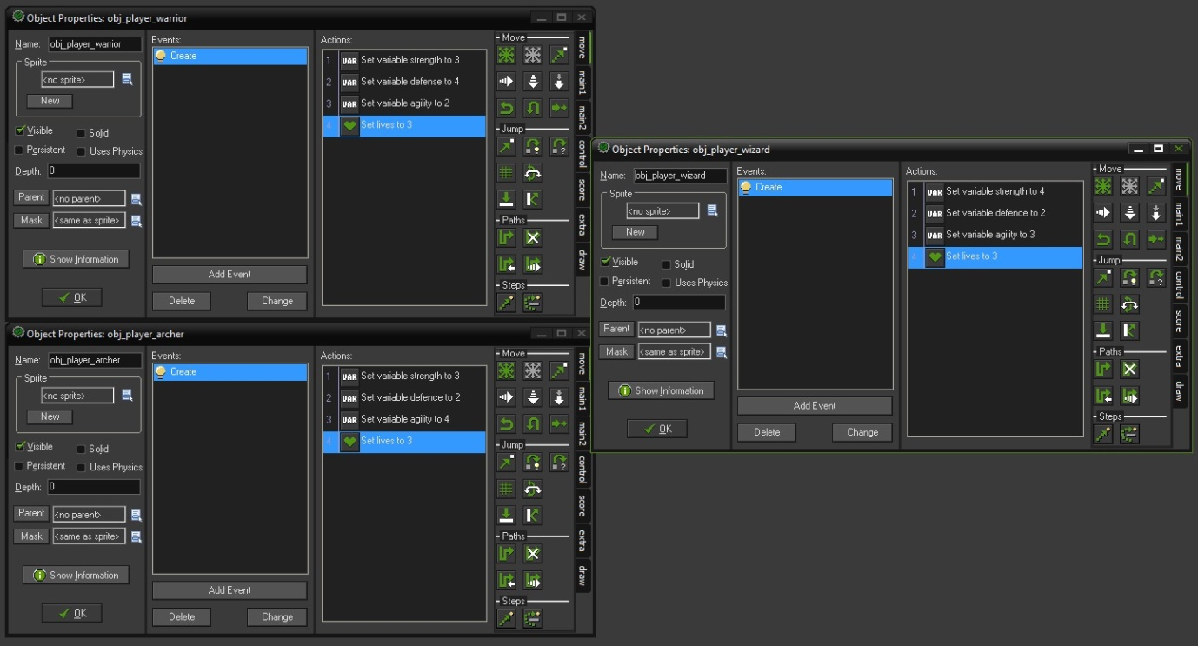
Objects can be used either outside of a battle or inside of a battle, some objects are passive which means they automatically apply their effects to a player when they have them in their equipped slots in a menu they can open outside of battle. But some objects such as food and potions can be used during battle and help the player (or monster) during battle.
For each attribute, they are set as variables. For monsters lives are set as variables but for players lives are set as the “set lives” option in the scoring tab.
As all objects I have created are parent objects, they can be duplicated over and over for different instances of the same object. For instance you can have 2 or 3 or more bread objects in the game or for example etc.

