Work So Far 27/11/13

So after adding all the artwork into GameMaker Studios, this is the outcome so far. The biggest issue was adding multiple sprites that change when an action is done. For example in the screenshot below of the title screen when the play scrolls over one of the boxes they highlight. This required a different sprite for each one.

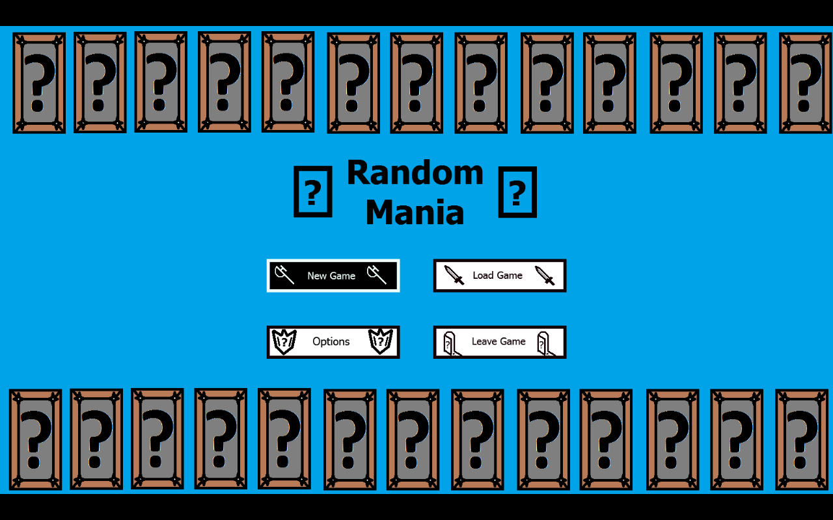

One issue we need to work on is possibly the addition of saving and loading game at a later date. We need to make that an issue when we’ve completed a portion of the game.
Options is another issue we should look at that changes various common things in a game such as the resolution etc etc. Again these should be at a later date.

The screenshot below is the character select screen at the moment. An issue we need to resolve here is that when a player chooses a class that affects the object in the next room.
When a player clicks a character portrait the other portrait is then unhighlighted and the text from the previous disappears. For example should I click wizard on the screenshot below then the warrior would unhighlight and the text on the right would change to be a wizards.
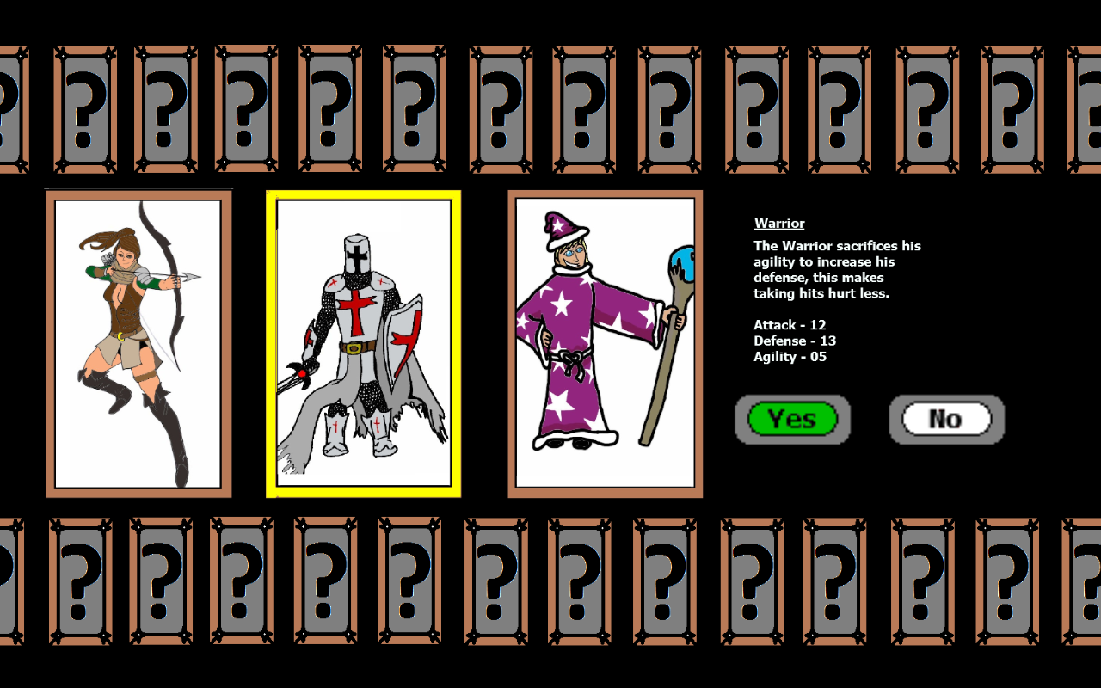

Clicking ‘No’ changes all the portraits to their default and clicking yes takes them to the next room. Again the issue we need to address is when the player chooses a character such as warrior then the object in the next room changes to a warrior. This needs to apply for all the other characters too

