Creating an .exe file
To create the .exe file follow the following guide.
Click on ‘Create Executable For target.
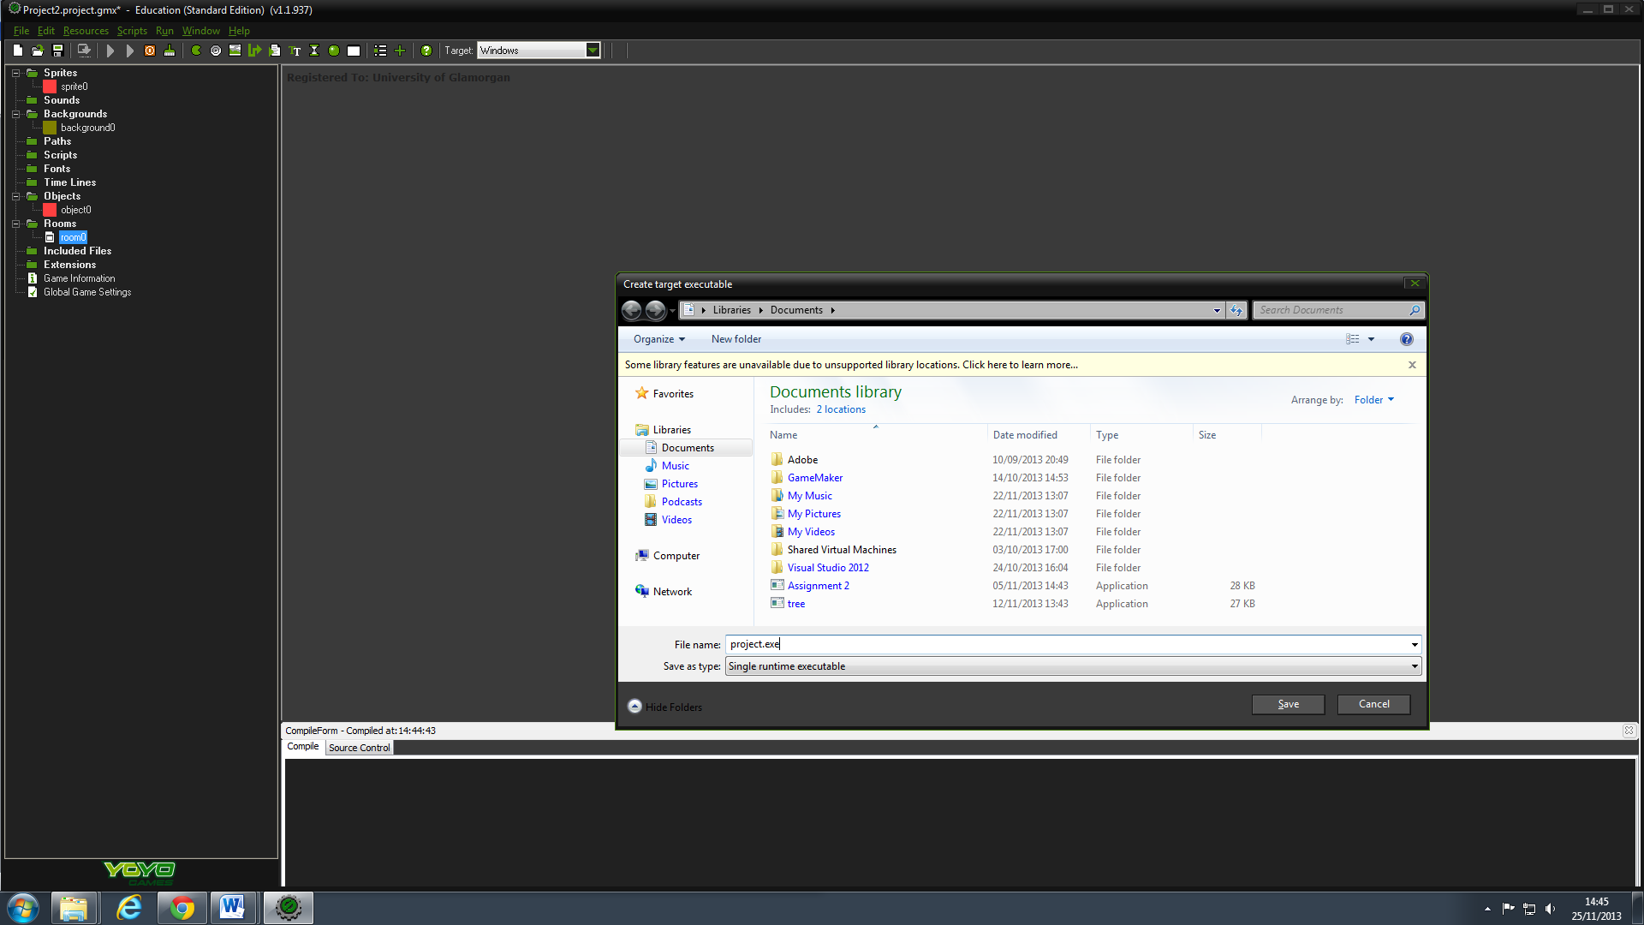
Save the file as project name. e.g. project.exe.
The image above shows the ‘project’ file is an .exe. and can be ran as an application from its saved location.

