How to setup your Android device for debugging

This tutorial assumes you have downloaded the android SDK to your machine.
1. Search for the USB drivers for your device
This link gets you started on some drivers, but for specific devices the search may be a little tougher.
2. Make sure you have your device set for usb debugging. 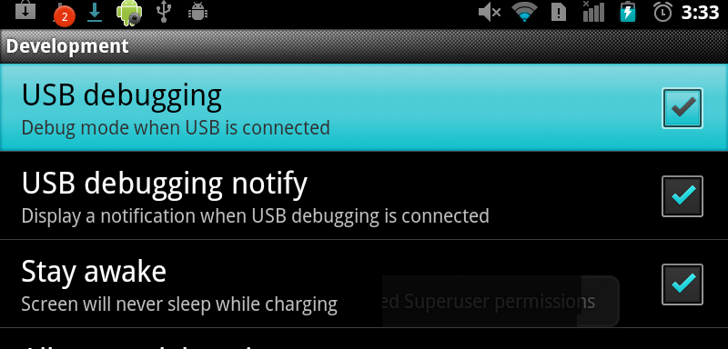
Here is another link for some help. The developer has a few tutorials on how to root android phones/devices, for these tutorials you mostly need USB drivers and he also has phone/device specific USB driver links.
3. Once you have the drivers set up you should be ok to go ahead and start debugging. There is a simple way to check.
4. Open the command prompt -> navigate to your android SDK directory -> type in “adb devices” and press Enter. You should see your device ID
