# Survey: Survey of ELN users in Cambridge Chemistry Department

Compiled: 05/19/2010

## Summary:

* Survey sent 29-Apr-10 to 41 scientists, 15 replies received
* 73% of respondents are PhD students, most are in first year
* Mostly organic chemistry, but good amount of Biological, Inorganic, Physical
* Approx. 50:50 usage of Local client vs via Terminal Server
* Approx equal Laptops vs Desktops
* 33% Win-7, 33% Mac; rest XP, Vista, Unix
* 40% use their own computer; 46% use group-owned computer
* 80% of computers used only by one person
* **60% have computer outside lab**. Only 7% have computer at the bench (Q9)
* **33% rate it as “Okay” to use computer for write-up**. 67% = Not Easy or Difficult (Q10)
* **20% have computer nearer than 4 metres from bench**. 33% are >10 meters (Q11)
* 20% don’t back-up files; 13% don’t know (Q12)
* 87% use paper lab notebooks to store text write-up. 47% use ELN (Q14)

## 1. What is your role in the Chemistry Department?

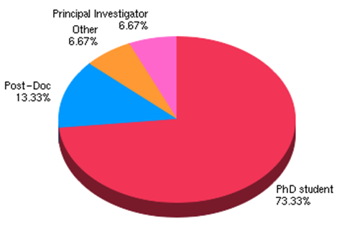

| **Value** | **Count** | **Percent %** |
| --- | --- | --- |
| PhD student | 11 | 73.33% |
| Post-Doc | 2 | 13.33% |
| Other | 1 | 6.67% |
| Principal Investigator | 1 | 6.67% |

## 2. ****How long**** have you been in this position?

## 

| **Summary** | | |
| --- | --- | --- |
| **Value** | **Count** | **Percent %** |
| 0 - 1 year | 10 | 66.67% |
| 1 - 2 years | 3 | 20.00% |
| 2 - 3 years | 2 | 13.33% |

## 3. What ****sort of chemistry**** do you work on? (select all that apply)

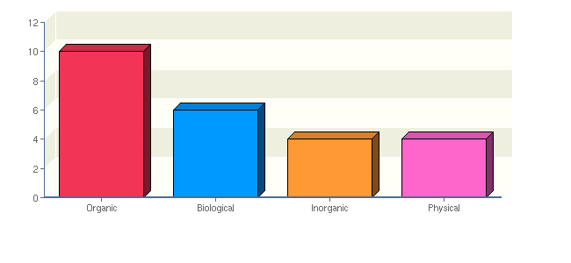

| **Summary** | | |
| --- | --- | --- |
| **Value** | **Count** | **Percent %** |
| Organic | 10 | 66.67% |
| Biological | 6 | 40.00% |
| Inorganic | 4 | 26.67% |
| Physical | 4 | 26.67% |

## 4. What is the main method that you use to access the department's ELN?

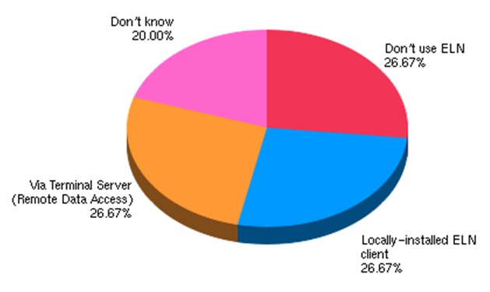

| **Summary** | | |
| --- | --- | --- |
| **Value** | **Count** | **Percent %** |
| Don't use ELN | 4 | 26.67% |
| Locally-installed ELN client | 4 | 26.67% |
| Via Terminal Server (Remote Data Access) | 4 | 26.67% |
| Don't know | 3 | 20.00% |

## 5. The following questions are about the main computer that you use in your lab or write-up area. What ****type**** of computer is it?

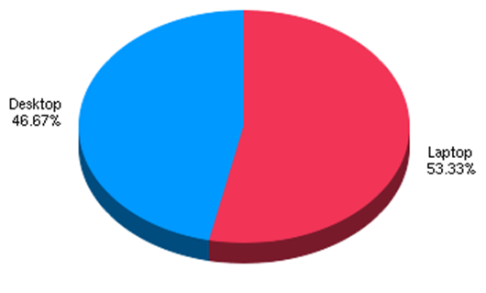

| **Summary** | | |
| --- | --- | --- |
| **Value** | **Count** | **Percent %** |
| Laptop | 8 | 53.33% |
| Desktop | 7 | 46.67% |

## 6. ****Which operating system**** does it use?

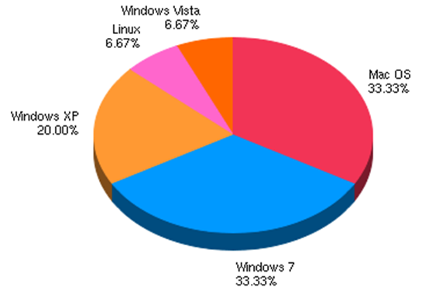

| **Summary** | | |
| --- | --- | --- |
| **Value** | **Count** | **Percent %** |
| Mac OS | 5 | 33.33% |
| Windows 7 | 5 | 33.33% |
| Windows XP | 3 | 20.00% |
| Linux | 1 | 6.67% |
| Windows Vista | 1 | 6.67% |

## 7. ****Who owns**** the above computer?

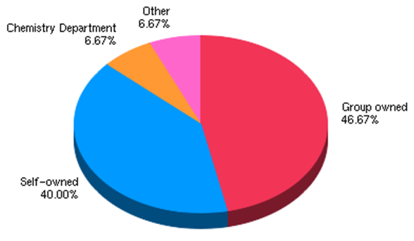

| **Summary** | | |
| --- | --- | --- |
| **Value** | **Count** | **Percent %** |
| Group owned | 7 | 46.67% |
| Self-owned | 6 | 40.00% |
| Chemistry Department | 1 | 6.67% |
| Other | 1 | 6.67% |

## 8. ****Who uses**** the above computer?

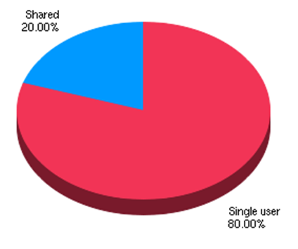

| **Summary** | | |
| --- | --- | --- |
| **Value** | **Count** | **Percent %** |
| Single user | 12 | 80.00% |
| Shared | 3 | 20.00% |

## 9. When you are using a computer to enter expt details, ****where**** is the computer located? (If you use a laptop, or you use two different computers to enter expt details, please indicate all locations that you commonly use)

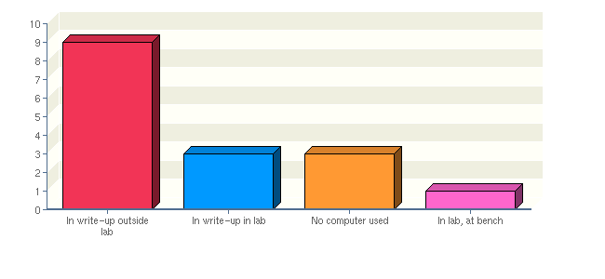

| **Summary** | | |
| --- | --- | --- |
| **Value** | **Count** | **Percent %** |
| In write-up outside lab | 9 | 60.00% |
| In write-up in lab | 3 | 20.00% |
| No computer used | 3 | 20.00% |
| In lab, at bench | 1 | 6.67% |

## 10. ****How practical is it**** to use this computer to record your experimental data whilst doing an experiment?

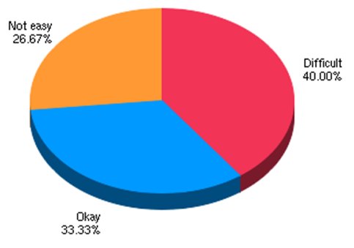

| **Summary** | | |
| --- | --- | --- |
| **Value** | **Count** | **Percent %** |
| Difficult | 6 | 40.00% |
| Okay | 5 | 33.33% |
| Not easy | 4 | 26.67% |

## 11. When working in the lab, ****how near are you**** to the above computer?

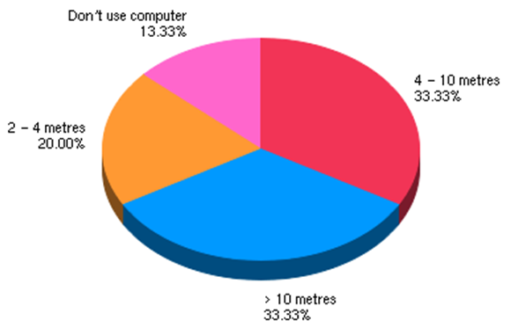

| **Summary** | | |
| --- | --- | --- |
| **Value** | **Count** | **Percent %** |
| 4 - 10 metres | 5 | 33.33% |
| > 10 metres | 5 | 33.33% |
| 2 - 4 metres | 3 | 20.00% |
| Don't use computer | 2 | 13.33% |

## 12. Do you ****back-up**** the experimental data files stored on the computer you use to any of the following locations? (Select all that apply)

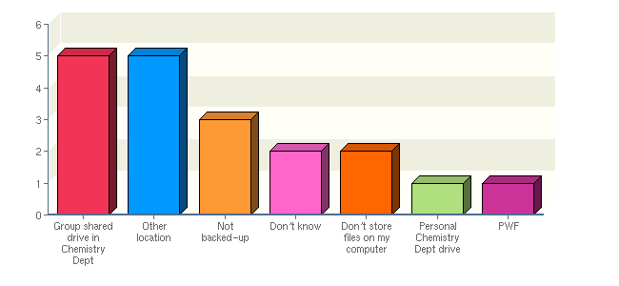

| **Summary** | | |
| --- | --- | --- |
| **Value** | **Count** | **Percent %** |
| Group shared drive in Chemistry Dept | 5 | 33.33% |
| Other location | 5 | 33.33% |
| Not backed-up | 3 | 20.00% |
| Don't know | 2 | 13.33% |
| Don't store files on my computer | 2 | 13.33% |
| Personal Chemistry Dept drive | 1 | 6.67% |
| PWF | 1 | 6.67% |

## 13. Where do you store the ****data files**** from your experiments(e.g. NMR, MassSpec, IR, Optical Dichroism, X-ray crystallography, etc) (select all that apply)

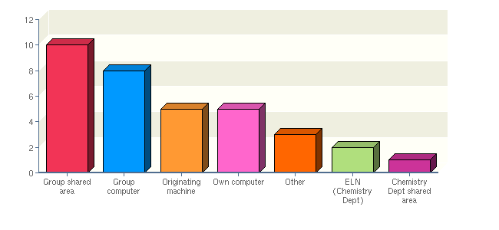

| **Summary** | | |
| --- | --- | --- |
| **Value** | **Count** | **Percent %** |
| Group shared area | 10 | 66.67% |
| Group computer | 8 | 53.33% |
| Originating machine | 5 | 33.33% |
| Own computer | 5 | 33.33% |
| Other | 3 | 20.00% |
| ELN (Chemistry Dept) | 2 | 13.33% |
| Chemistry Dept shared area | 1 | 6.67% |

## 14. Where do you record the ****textual details**** of your experiments?(e.g. methods, observations, conclusions) (select all that apply)

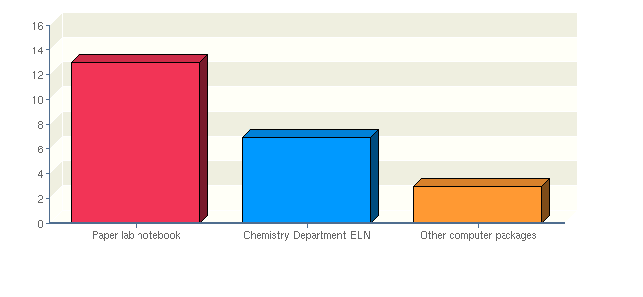

| **Summary** | | |
| --- | --- | --- |
| **Value** | **Count** | **Percent %** |
| Paper lab notebook | 13 | 86.67% |
| Chemistry Department ELN | 7 | 46.67% |
| Other computer packages | 3 | 20.00% |

## 15. ****What proportion**** of your experimental information do you store in the Chemistry Dept's ELN? (Estimate this using number of items of data, rather than counting byte sizes)

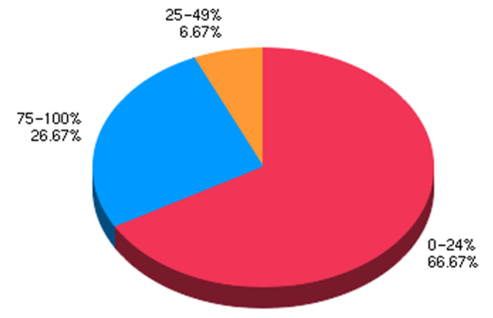

| **Summary** | | |
| --- | --- | --- |
| **Value** | **Count** | **Percent %** |
| 0-24% | 10 | 66.67% |
| 75-100% | 4 | 26.67% |
| 25-49% | 1 | 6.67% |

## 16. How much do you agree with the following statements:

## 

## 

## 

## 

## 

**Total Responses: 15**

## 17. What would encourage you to use the ELN more?

| **Value** | **Count** | **Percent %** |
| --- | --- | --- |
| a web client may be more useful (I recognise that the specialised OS, software and datatypes used by NMR are rather low priority for more synthesis-minded users) | 1 | 10.00% |
| Being able to input and edit experiments at the bench | 1 | 10.00% |
| If I had time to get to grips with it. I don't find it easy to use and I don't have time to invest in it such that it becomes easy. Perhaps over the summer I can do this. | 1 | 10.00% |
| If it was more easily accessible. If I could use my computer in the lab. Essentially, as a sine qua non of success, the ELN has to be quicker than using pen and paper; this is not currently the case. It would be nice for the UI to have common tasks available as large buttons (new expt, insert detail) - for unanimous departmental usage it needs to be accessible by people with far less technical know how (the group in the early adopters team is certainly biased towards the more adept). | 1 | 10.00% |
| improvement 1) | 1 | 10.00% |
| linking it with a chemical invnetory and having access to the ELN from my fumehood. | 1 | 10.00% |
| more training | 1 | 10.00% |
| potability | 1 | 10.00% |
| See above. Answered on behalf of group's users. | 1 | 10.00% |
| The main reason I don't use the ELN is the fact that the computers I use are shared, and not at the bench, so it just isn't practical - I would recommend it to people who do more theoretical work as I think in the right setting it would be a valuable tool. | 1 | 10.00% |

## Appendix: 19. What are the three most important areas to improve in the ELN?:1)

| **Description of Improvement** |
| --- |
| connection to internet data sources |
| Input and edit experiments at the bench |
| Putting in tables in the text editor, make them more user friendly |
| access to TS from the NMR machines (RedHat outdated version) is impossible. All experimental details that I need to run an NMR experiment, therefore, cannot be directly input into the ELN. I have attempted compiling rdesktop so that it is the most updated |
| The speed. |
| Entering data in lab environment - appropriate hardware |
| Better link between Chemdraw and ELN interface |
| more viewers to be able to view my data |
| If I could access it from my laptop, I would use it. In my lab there are only 2 computers near the fumehoods which access ELN and even they are quite far. |

https://app.sgizmo.com/images/sep.jpg

## Appendix: 20. What are the three most important areas to improve in the ELN?:2)

| **Description of Improvement** |
| --- |
| integration of group reagents/ordering system |
| to be able to create folders in the experiment section rather than just a list of experiments |
| 2D NMR data - most experiments I am trying to develop are 2D, which stores as a 'ser'... serial fid? The processed (2D fourier transformed) data is stored one level deeper -- 2rr probably contains the 2D real data. |
| Compatibility with non-standard batch chemistry. It is often difficult to describe flow chemistry setups in the ELN because the drawing package isn't good enough. |
| More reliable - prevent crashing |
| easy accessibilty to eln when working in different labs. |
| Getting things signed by your supervisor is more time consuming in ELN. |

https://app.sgizmo.com/images/sep.jpg

## Appendix: 21. What are the three most important areas to improve in the ELN?:3)

| **Description of Improvement** |
| --- |
| to be able to paste word in the text editor withoout formatting problems |
| Ability to display FIDs as FIDs instead of spectrum - although in principle there is no loss in information on FT it is easier to spot siignal intensity problems and arciing issues. |
| Reducing the amount of text that has to be added (i.e. selecting TLC eluent and detection method from a menu rather than typing them out for every TLC photo. |
| Faster client version |
| I wish I could carry around eln as i can my notebook |

https://app.sgizmo.com/images/sep.jpg