

JISC Project Plan – CLARION Project

Overview of Project

1. Background
Science is neither cheap nor easy. Large amounts of money and effort are expended by universities and other research organisations in progressing mankind’s scientific knowledge. Scientific discovery progresses based on the knowledge of others; one of the challenges to the information science community is to increase the sharing and use of the experiences and results of researchers across the world.

This presents two challenges. The first is to capture the experiences in a form that facilitates sharing – for example, on computers. The second is to make the information as useful as possible by adding structure and context to the information, thus enhancing its meaning. The CLARION Project (Chemical Laboratory Repository In/Organic Notebooks) will work on both these challenges. CLARION will enhance the collection and usage of chemistry experiment data for the research scientists in the University of Cambridge Chemistry Department.

At present in the Chemistry Department there is no consistent approach to the storage of scientific data. Researchers mostly store their experiment data into a paper lab notebook. Limitations of the paper format mean that these results are accessible by a minority of scientists, thus constraining the potential reuse of experience and knowledge.

The Chemistry Department does make some use of computers for storing research information. There is a repository within the department, but this only stores one type of chemistry data (crystallographic). Scientists use their personal computers to prepare documents such as papers and theses, and to handle results in spreadsheets. However, the organisation and form of storage varies from person to person, so that across the department a variety of file types, storage locations, data formats, databases, metadata, and access controls are used. The lack of a consistent organising framework again limits the accessibility of the data, and therefore its potential usability.

The chemistry leaders have therefore initiated a project to deploy an electronic lab notebook (ELN) to the researchers in the department. A commercial ELN has been selected and will be in use towards the end of 2009.

The ELN is an excellent tool for solving the data management activities necessary for the day-to-day collection and handling of scientific data. What the ELN is less good at is adding semantic definition to the data in order to facilitate its use. Prof. Peter Murray-Rust’s group have extensive experience of semantic tools such as CML (Chemical Markup Language) and RDF (Resource Descriptor Framework) and applying them to chemical data. The CLARION project will work closely with the ELN team to apply these techniques to experiment data from the chemistry department. Additionally, the project will establish a system to allow scientific results to be made accessible by researchers outside the department.

Finally, if data are to be stored electronically, then provision must be made for the storage systems to be supported, and data to be stored in long-term accessible formats. CLARION will investigate the possible models for ensuring such long-term sustainability.

2. Aims and Objectives
The aims of the CLARION project are to:
- Enhance the Chemistry Department’s existing repository to enrich semantic context of chemical data
- Interoperate with the Chemistry Department’s ELN tool that collects and manages experiment information (by working closely with the ELN team)
- Establish automated mechanisms for feeding data into the repository
- Make subsets of data available to scientists outside the chemistry department, with particular reference to Open Data
- Increase the efficiency with which research can be carried out in the department. For example by:
  - Facilitating resource discovery thus preventing unnecessarily repeating experiments
  - Assisting in information collation
  - Facilitating manuscript creation
- Define models for the sustainability of the systems developed
- Publicise the systems developed and the findings from the project

The CLARION project will:
- Extend the existing Cambridge repository to:
  - Expand the breadth of data to include NMR spectra, mass spectra and synthetic procedures (reactions)
  - Load data from existing data puddles into the repository
- Help establish use of the ELN in the Chemistry department by working with the ELN team to:
  - Implement the ELN to replace paper lab notebooks
  - Champion the ELN as the tool for everyday collection and interaction with experiment data
  - Provide links to export data to the repository which enhance semantic definition
- Facilitate and promote the publication of Open Data
- Develop a business model for the continued support and expansion of the repository

3. Overall Approach
The introduction of a commercial ELN is a major step in managing scientific data. The ELN will handle the everyday interactions that scientists have with their data – recording the objective of the experiment and the method used; collecting raw and processed data; recording observations and conclusions. Additionally, the ELN has the potential for helping the scientist with things such as recording radioactivity usage; Health & Safety compliance; tracking controlled substances; linking to other systems in the department such as stores; requests for analytical services, etc.

Figure 1 is a Gantt chart showing the major project phases. For the CLARION project, a big question is the extent that the ELN is able to use the semantic techniques (CML, RDF) that the project wishes to use in order to improve data usability. The early part of the project will therefore involve building an understanding of the capabilities of the ELN. The timings for these investigations are dependant on final approval of the contract with the ELN vendor.

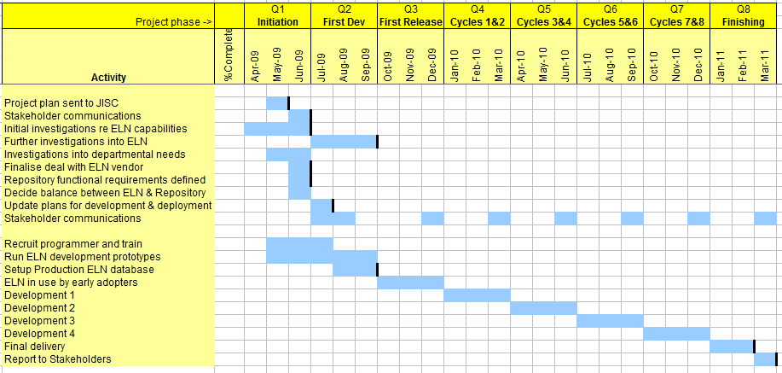
Fig. 1: Gantt chart showing high-level project activities and timings. See Appendix B for a detailed analysis of the workpackages

In parallel with the investigations into the ELN’s capabilities, the project will work with departmental scientists to identify scientists’ needs and identify early adopters. Based on the results from these investigations, the project will decide how the final solution will be architected, identify the areas of effort needed, and produce a plan for the remainder of the project.

Towards the end of the project, investigations will be made into how the solutions developed by the project could be supported after the project is finished. This will allow the chemistry department to decide on how they would like to support it. The actual implementation of the chosen support method is outside the scope of the project.

4. Project Outputs
Outputs from CLARION will be (in order of tangibleosity):

- An enhanced repository that stores research chemical information together with its semantic context
- Multiple types of chemical data stored within the repository
- An interface to the ELN that automatically marks-up experiment data to enhance semantic context and store the results into the repository
- An interface to allow external users to access information in the repository
- Blog postings and project webpages documenting project details & learnings
- A report to JISC on results and learnings from the project, especially describing our experiences in
  - Integrating data publication in the scientist’s workflow
  - implementing an ELN within an academic research chemistry department
  - using CML and RDF across different software systems

5. Project Outcomes
Outcomes from the project are expected to be:

- The Department will have a local repository filled with recent research output which will be re-used for research planning, quality checking, teaching and learning in undergraduate courses.
- The departmental services will be evangelized to the value of data repositories and will have built repository deposition processes into their business.
- The synthetic chemistry groups will have interfaces to the ELN and a repository of searchable theses.
- All software will be Open and much valuable data will be public and Open.
- The report will analyze which processes are sustainable and how, and provide a template for other institutions.
- The Chemistry Department will benefit from a cutting-edge data management system
- JISC community will benefit from learning experiences learned whilst introducing and ELN and data repository system in an academic research environment. Learning will include cultural factors, technical factors, motivations & benefits to users, and costs.
- A quantity of research data currently gathering dust will be freed into the public domain or openly-licensed.

6. Stakeholder Analysis
The key stakeholders for the CLARION project are shown in the following table:

Stakeholder | Interest / stake | Importance
Chemistry Department | The JISC call is at an ideal time for the department which is committed to deploying and supporting an ELN. It helps the department to evaluate the issues, have a higher bargaining power with the vendor, gain greater publicity, and address sustainability in a public and considered manner. Also, the department needs to incorporate historic and future instrumental data into a repository. | Highest
CLARION project Steering Committee | The steering committee is composed of scientists around the country who are either potential users of a repository such as CLARION’s, or who are working in a similar IT field. | High
JISC | This will be a key exemplar of a repository centred on data and supported by a department. JISC will obtain in-depth analyses of the need to capture data, challenges in implementation, policies (embargo, data licensing), and working with commercial vendors. | High
Repositories community | Will see an early example of a departmental repository, filled by the scientists and with software and protocols that are widely re-usable. The role of commercial vendors in supporting data reposition will be publicly analysed. | High
Murray-Rust Group | Will see its semantic chemical technologies deployed in a production environment and cement its role as a leader in molecular informatics or real relevance to chemistry. | Medium
ELN vendor | The ELN is key to the desired goal of capturing data in digital form as early as possible. CLARION will work closely with the vendor to add semantic value to the data gathered in the ELN. | Medium

7. Risk Analysis
The risks to the project are summarised in the table below:

Risk | Probability  (1-5) | Severity  (1-5) | Score  (P x S) | Action to Prevent/Manage Risk
Staffing
Inability to hire qualified staff | 2 | 5 | 10 | Transfer staff from other projects. Limit breadth of sub-domains
Key staff leave early | 3 | 3 | 9 | Develop on narrow fronts so always leaving a useful working solution
Organisational
Academic staff sceptical and uncommitted | 3 | 5 | 15 | Choose key evangelists and enhance in-house advocacy. Find external example of advocacy
Analytical service staff cannot /will not operate repository | 3 | 5 | 15 | HOD and Comp Officers provide extra initial support. SLA agreed with services
Technical
Repository technology difficult to create | 2 | 5 | 10 | Adapt Fedora technology
External suppliers
Department fails to select, buy or deploy ELN | 3 | 3 | 9 | Extension of CLARION to provide the most cost-effective capture of chemistry from alternative sources
Legal
Lack of agreement with ELN vendor | 2 | 3 | 6 | Consider vendor’s attitude as part of vendor selection

8. Standards
Name of standard or specification | Version | Notes
CML (Chemical Markup Language) | 2.5 | CML is an XML-based rich format for capturing a spectrum of chemical information
RDF (Resource Description Language) | Latest released version | RDF is the standard adopted by the W3C committee for semantic enrichment of information on the web.
ELN APIs from <vendor> | Latest released version | The ELN vendor was selected by the Chemistry Dept partially on the basis of  the availability of APIs to interoperate with the ELN.
SPARQL | 1 | We will provide a SPARQL end-point into the Open Data published by CLARION
ORE | 1 | Where appropriate, we will use the ORE vocabulary to describe collections of data.
HTTP | 1.1 | APIs provided for OpenData will be RESTful.

9. Technical Development
The early part of the project will focus on investigations into the capabilities of potential software, in particular the ELN. The desire is to understand whether semantic techniques can be built into the ELN, or if interfaces have to be built to extract data to an external repository.

The project will use the philosophy of prototyping, releasing each prototype to the early-adopter users in order to get real feedback on needs and usability. Prototypes will be released in 6-week development cycles. Each cycle consists of:
- 0.5 weeks feedback from previous deployment
- 2 sprints of 2 weeks of development
- 1.5 weeks delivery of next phase and training

The user community (e.g. crystallography) then has one or two six-week periods before their next cycle. In this way there is effectively continuous development and integration at a pace acceptable to scientists where predicted careful release is more important than “release early, release often”.

10. Intellectual Property Rights
Intellectual Property discovered or developed by the CLARION project will be the property of the University of Cambridge. The Chemistry Department’s contract with the ELN vendor does allow for joint commercialisation of jointly-developed software tools, but CLARION resource will not be used in this way. A goal for CLARION is to enable project deliverables to be open and available for use by other academic institutions, so this will be a factor in the design of the technical architecture adopted.

Software created by the CLARION project will be licensed under an Apache-style license, unless constrained by a dependent library’s license (e.g. GPL).

Project Resources

11. Project Partners
The CLARION project does not have any formal project partners. However, it is working closely with the chemistry department’s computing group; the head of this group (Dr Tim Dickens) is a member of the CLARION project team. The chemistry department is at present finalising a contract to collaborate with the ELN vendor, giving the vendor access to the chemical applications and tools developed by Prof Murray-Rust’s team. Thus the ELN vendor will have access to CLARION deliverables, and could be loosely considered as a project partner. The contract with the ELN vendor is expected to be completed by the end of May ’09. Any intellectual property created by CLARION will remain the property of the University of Cambridge.

12. Project Management
Project management framework: The diagram shows the project organisation, governance structure, and reporting relationships. Numbers indicate percentage of time dedicated to CLARION:

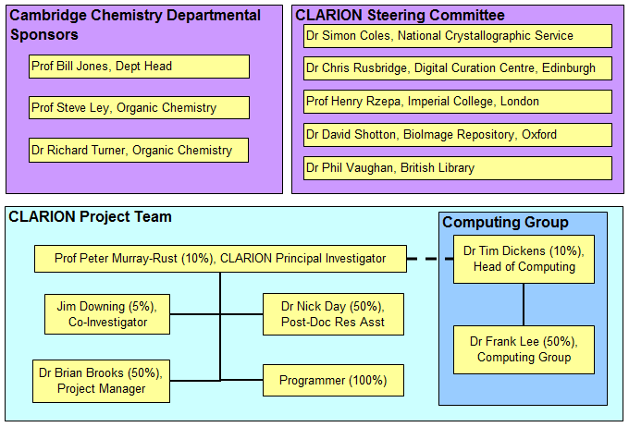

Decision process: Everyday project decisions will be made within the CLARION project team, with Prof Murray-Rust having final say. Larger, more strategic decisions will be taken to the departmental sponsors and to the Steering Committee for guidance, with Prof Murray-Rust again having the final say.

Project team members: The table below shows the team members, their roles, and their contact details:

Role | Initials | Name | Contact details | %FTE
Principal Investigator | PMR | Prof. Peter Murray-Rust | Pm286@cam.ac.uk  Wk: 01223-763069 | 10%
Co-Investigator | OJD | Jim Downing | Ojd20@cam.ac.uk  Wk: 01223-763073 | 5%
Chem Dept mgr | TKD | Dr Tim Dickens | Tkd25@cam.ac.uk  Wk: 01223-763811 | 10%
Chem Dept Computing Officer | FL | Dr Frank Lee | Rl201@cam.ac.uk | 30%
Post-doc Research Assistant | NED | Dr Nick Day | Ned24@cam.ac.uk  Wk: 01223-763073 | 50%
Programmer | ??? | ??? | ???@???.??.?? | 100%
Project manager | BJB | Dr Brian Brooks | Bjb45@cam.ac.uk  Wk: 01223-763-073 | 50%

Training: The project members will need to have a good appreciation of the capabilities of the ELN. This will be built using the close relationship that is developing between the ELN and the chemistry dept. Training on other IT tools used by the project is expected to be by private study and by making use of the expertise of other members of Prof Murray-Rust’s group. Training of scientist users will be using methods such as 1x1 tutorials, presentations, and online training techniques.

13. Programme Support
It is likely that we will be adopting Fedora as the basis of the CLARION software, and it is likely that the developer will not have specific Fedora experience when recruited. Any training available from the Repositories Support Project on Fedora and / or Linked Data would be welcome.

Our Project Manager is a JISC first-timer, so support in general matters of JISC processes and documentation would be most valuable.

14. Budget
The JISC contribution to the project is 69% of the total cost, and the Chemistry Department’s contribution is 31% of total cost.

See Appendix A for budget details. The budget is currently being re-costed to reflect current status.

Detailed Project Planning

15. Workpackages
See Appendix B for details of Workpackages.

16. Evaluation Plan
The table below summarises the ways in which project success will be evaluated:

Timing | Factor to Evaluate | Questions to Address | Method(s) | Measure of Success
Each development cycle | Functionality | - Does the software do what’s intended?  - Is it intuitive? | User testing and feedback | Satisfaction level of users; are suggestions made or issues raised regarding functionality?
Each development cycle | Performance | - Is performance acceptable? | User testing and feedback | Satisfaction level of users; are issues raised regarding performance?
Each development cycle | Stability | - Does the software hang or crash? | User testing and feedback | Satisfaction level of users; are issues raised regarding stability?
Continuous during project | Code quality | - Is the code well factored, with adequate unit testing etc? | Team code review | Glide path of tracked issues.
Continuous during project | Data volumes | - Has existing data been loaded and made available?  - Is new data being added? | Monitoring data volumes in repository | Total number of digital objects in repository. Percentage of available departmental digital objects added
Continuous during project | Data quality | - Completeness of data and metadata  - Usability of data | Automatic validation of semantic data objects | Successful conversion to CML and to RDF
Project’s last quarter | Documentation – Code | - Is the documentation comprehensive, understandable, adequate? | Team code review | Feedback from team
Project’s last quarter | Documentation – Reports | - Does the report cover all issues, is it clear? | Submission to stakeholders | Feedback from stakeholders

17. Quality Plan
The following table shows the quality criteria that the project will use:

Output
Timing | Quality criteria | QA method(s) | Evidence of compliance | Quality responsibilities | Quality tools  (if applicbl)
Each development cycle | Validation testing | Use defined data sets and user procedures. | Check for expected output | Dev, NED, BJB
Each development cycle | Regression testing | Use standard data sets and user procedures | Check responses still as expected | Dev, NED, BJB
Each development cycle | Acceptance testing | Scientist testing & feedback | Behaviour as expected by scientist | Dev, NED, BJB, Scientist
Continuous during project | Data quality | Manual inspection | Success of manual data loading events | Dev, NED, BJB | JUMBO converters
Continuous during project | Data quality | Automatic validation | Successful automatic loading of data into repository | Dev, NED, BJB | JUMBO converters

18. Dissemination Plan
Dissemination plans for the project are as follows:

Timing | Dissemination Activity | Audience | Purpose | Key Message
Dec-09 | International Digital Curation conference | Digital repository community – owners & managers & digital librarians | Publicise the project plan, and early achievements. | <- As purpose
Spring ‘11 | ELN vendor conference | Scientific research community | Publicise the availability of the software deliverables, and the Open Data resource in the repository, plus the use of ELN within academic environment, with its use as a feed into the Repository | Ditto
Spring ‘11 | Major chemistry conference | Scientific research community | Ditto | Ditto
Spring ‘11 | Open Repositories 11 | International HEFE information management community | Experiences in integrating repositories with workflow, lessons learnt from ELN roll-out. Success / failure in engaging scientists with publication of Open Data

19. Exit and Sustainability Plans
The following table shows the exit and sustainability plans for CLARION:

Project Outputs | Action for Take-up & Embedding | Action for Exit
Sustainability proposals | Investigate possible approaches for business sustainability, write up report and make available | Send report to JISC and Chemistry Dept stakeholders. Make available on project website (which is part of the Chemistry Dept’s website, and will therefore persist after project ending)
Learnings from the project | Prepare report covering learnings, submit to JISC. Make available for download from project website | Ditto
Source code | Make available via Project website and via Sourceforge / gcode.  Encourage ELN vendor to deploy software with existing and future customers | Ensure documentation is up to scratch.
Repository | Continue to run on hardware purchased by the project. | To be defined in the Sustainability Proposal Report. Chemistry dept will consider the possible approaches in the report and decide as appropriate.
Repository contents | Discuss potential for Institutional Repository to provide long-term curation of data in case of disaster / non-continuation of repository. | Live test of content archiving to IR.

The next table shows project outputs that may have potential to live on after the project ends and how they might be taken forward:

Project Outputs | Why Sustainable | Scenarios for Taking Forward | Issues to Address
Software deliverables – Repository software, interfaces, data markup & loading tools | This is the essence of the CLARION project’s deliverables. They will enable collection and semantic enhancement of chemistry data, and provide storage mechanisms that make these data openly available. | An analysis of the possible and recommended scenarios is a deliverable of the project | - How to host the applications  - How to update infrastructural software  - How to maintain the application code  - How to maintain any security models

Appendixes

Appendix A. Project Budget

JISC Project Project Plan Budget Template

Directly Incurred Staff | Year 2009 | Year 2010 | Year 2011 | TOTAL £
Post, Grade & % FTE | £ | £ | £ | £
Total Directly Incurred Staff (A)
Non-Staff
Travel and expenses
Hardware/software
Dissemination
Evaluation
Other | £ | £ | £ | £
Total Directly Incurred Non-Staff (B)
Directly Incurred Total (A+B=C)
(C)
Directly Allocated
Staff | £ | £ | £ | £
Estates
Other
Directly Allocated Total (D)
Indirect Costs (E)
Total Project Cost (C+D+E)
Amount Requested from JISC
Institutional Contributions
Percentage Contributions over the life of the project |  | JISC | Partners | Total

Nature of Institutional Contributions
Directly Incurred
Staff
Post, Grade & % FTE | £ | £ |  | £
Directly Incurred Non Staff
Hardware/Software etc. | £ | £ |  | £
Directly Allocated
Staff, Estates etc. | £ | £ |  | £
Indirect Costs
Indirect Costs | £ | £ |  | £
Total Institutional Contributions | £ | £ |  | £

Appendix B. Workpackages

WORKPACKAGES | Month | 1 | 2 | 3 | 4 | 5 | 6 | 7 | 8 | 9 | 10 | 11 | 12 | 13 | 14 | 15 | 16 | 17 | 18 | 19 | 20 | 21 | 22 | 23 | 24
1: Stakeholder management |  |  | X | X |  |  |  |  |  | X |  |  |  |  |  | X |  | X |  |  |  | X |  | X | X
2: Communications |  | X | X | X | X | X | X | X | X | X | X | X | X | X | X | X | X | X | X | X | X | X | X | X | X
3: Project management |  | X | X | X | X |  | X |  |  |  |  |  | X |  |  |  |  |  | X
4: Electronic Lab Notebook |  | X | X | X | X | X | X | X | X | X | X | X | X | X | X | X | X | X | X | X | X | X
5: Chemistry Repository |  |  | X | X | X | X | X | X | X | X | X | X | X | X | X | X | X | X | X
6: Repository Client |  |  |  |  | X | X | X | X | X | X | X | X | X | X | X | X | X | X | X | X | X | X
7: Sustain & disseminate |  |  |  |  |  |  |  |  |  |  |  |  |  |  |  |  |  |  |  |  |  | X | X | X | X
8:
9:
10:

Project start date: 1st April 2009
Project completion date: 31st March 2011
Duration: 24 months

 |  |  |  | Milestone | Responsibility

WORKPACKAGE 1: Stakeholder management

Objective: Ensure that CLARION’s stakeholders have input into the project and that they receive progress reports
- Engage internal stakeholders | May-09 | Dec-09 |  |  | PMR/NED/BJB
- Engage external steering committee | May-09 | Mar-11 | Completion report to stakeholders | Y | PMR/NED/BJB
- SteeringCmtee assess user feedback | Jun-09 | Aug-09 |  |  | BJB
- Steering Committee meeting | Jun-09 | Sep-09 |  |  | BJB
- Business model analysis to JISC & Dept | Dec-10 | Apr-11 | Business model report to department stakeholders and to JISC | Y | BJB
- Steering Committee evangelism mtg | Aug-10 | Dec-10 |  |  | PMR/BJB

WORKPACKAGE 2: Communications

Objective: Ensure that CLARION’s users plus other interested parties are aware of the project and its results
- Internal workshops | Jun-09 | Dec-09 |  |  | PMR/NED/BJB
- External workshops | Sep-09 | Jun-10 |  |  | PMR/NED/BJB
- Conference presentations | Sep-09 | Mar-11 |  |  | PMR/NED/BJB
- Blog postings | May-09 | Mar-11 |  |  | PMR/OJD/BJB

WORKPACKAGE 3: Project Management

Objective: Ensure that the CLARION project progresses smoothly, delivering results on time and on budget
- Recruit project manager | Apr-09 | Apr-09 |  |  | OJD
- Recruit developer | May-09 | Aug-09 |  |  | OJD/BJB
- Deliver project plan | May-09 | May-09 | Project plan document | Y | BJB
- JISC progress reports | Sep-09 | Sep-10 | Progress report documents |  | BJB

WORKPACKAGE 4: Electronic Lab Notebook

Objective: Ensure that the ELN is successfully deployed to scientists within the Chemistry dept, and that it feeds data into the Repository
- Needs-analysis and design:
- Contract signed for ELN | May-09 | Jun-09 |  |  | TKD
- Analysis of scientists’ needs | May-09 | Aug-09 | Requirements documents |  | NED/BJB
- Investigations into capabilities of ELN | May-09 | Sep-09 |  |  | FL/NED/OJD/BJB
- Agree business rules for data visibility | May-09 | Sep-09 | Agreed business rules |  | FL/NED/BJB
- Plan for deployment of ELN | May-09 | Sep-09 | ELN deployment plan |  | TKD/FL
- Setting up environments:
- Development environment for ELN | May-09 | Jun-09 | ELN Development environment |  | FL
- Produce prototype configurations of ELN | Jun-09 | Sep-09 | ELN prototypes |  | FL
- Hardware for ELN Production environment | May-09 | Sep-09 | ELN Production environment |  | FL
- Production configuration for ELN | Sep-09 | Oct-09 | ELN configured for use |  | FL/NED/OJD/BJB
- Refinements to ELN configuration | Dec-09 | Dec-10 |  |  | FL/NED/OJD/BJB
- Rolling out to users:
- ELN deployment to early adopters | Oct-09 | Dec-09 | ELN in use by early adopters | Y | FL/NED/TKD/BJB
- ELN deployment to wider user base | Dec-09 | Dec-10 | ELN in use by later adopters |  | FL/NED/TKD/BJB
- Exporting data to Repository:
- Manual export of data to Repository | Jun-09 | Jun-10 | Data in CLARION Repository | Y | Dev/FL/OJD/NED
- Develop automatic process for data export to Repository | Jun-09 | Jun-10 | Software for loading data into Repository |  | Dev/FL/OJD/NED
- Automated data export to Repository in use | Jun-09 | Aug-10 | Data being automatically loaded into CLARION Repository | Y | Dev/FL/OJD/NED

WORKPACKAGE 5: Chemistry Repository

Objective: Develop a semantic repository for chemical information and establish feeds of data into it
- Needs-analysis and design:
- Functional requirements for Repository | Jun-09 | Sep-09 | Repository Requirements specification document |  | NED/OJD/PMR/BJB
- Architecture plan for Repository | Jun-09 | Oct-09 | Repository architecture design plans |  | Dev/OJD/PMR/BJB
- Repository development:
- Set up Development environment for Repository | May-09 | Nov-09 | Repository Development environment |  | Dev/OJD/FL/TKD
- Develop & configure Repository | Jun-09 | Mar-10 | Learnings over Repository configuration |  | Dev/OJD
- Set up Production environment for Repository | Dec-09 | Jun-10 | Repository ready for accepting data | Y
- Add SOLR index to Repository | Mar-10 | Mar-11 | Index into words in the Repository | Y | Dev/OJD/NED
- Data loaders:
- Develop basic manual data loader for Repository | Jul-09 | Feb-10 | Software for manual loading of data |  | Dev/OJD/NED/BJB
- Specifications for interface from ELN to Repository | Jun-09 | Oct-09 | Interface specifications document |  | Dev/OJD/NED/BJB
- Prototypes of ELN-Repository data export interface | Jul-09 | Dec-10 | Prototype software & learnings about issues |  | Dev/OJD/NED/BJB
- Develop V1 ELN-Repository interface for data export | Aug-09 | Mar-10 | Software for getting data out of ELN |  | Dev/OJD/NED/BJB
- Manually-initiated data export from ELN to Repository | Feb-10 | Dec-10 | Method for scientist to initiate transfer of data from ELN to Repository | Y | Dev/OJD/NED/BJB
- Automated data export from ELN to Repository | Jun-10 | Mar-11 | Method for scientist to set up automated transfer of data from ELN to Repository | Y | Dev/OJD/NED/BJB
- Loading data:
- Transfer C3DER data to Repository | Jun-09 | Dec-09 | Data in CLARION Repository | Y | NED/OJD
- Add crystallographic data puddle to Repository | Sep-09 | Sep-10 | More data in CLARION Repository | Y | NED/OJD
- Load spectroscopy data puddles into Repository | Oct-09 | Oct-10 | Even more data in CLARION Repository – different sort of data too | Y | NED/OJD

WORKPACKAGE 6: Repository client

Objective: Develop a web-browser client to allow querying and browsing of data in the Repository
- Define needs for querying & browsing Repository | Jul-09 | Dec-09 | Client application Requirements document |  | NED/OJD/PMR/BJB
- Investigate available applications for querying Repository | Jul-09 | Dec-09 | Decision on which client to use for CLARION |  | NED/OJD/PMR/BJB
- Develop Prototype Repository client | Jul-09 | Jun-10 | Client prototype |  | Dev/OJD/NED/BJB
- V1 client for internal users to search & browse Repository | Dec-09 | Dec-10 | Client app for querying CLARION Repository | Y | Dev/OJD/NED/BJB
- Refine client & Repository for use by external users | Jun-10 | Mar-11 |  |  | Dev/OJD/NED/BJB
- V2 client for Repository access by external users | Sep-10 | Mar-11 | Improved querying Client app | Y | Dev/OJD/NED/BJB
- Refine client to allow use of SOLR indexes | Sep-10 | Mar-11 |  |  | Dev/OJD/NED/BJB
- V3 interface for Repository access using SOLR indexes | Dec-10 | Mar-11 | Client app for textual querying of Repository | Y | Dev/OJD/NED/BJB
WORKPACKAGE 7: Sustain & disseminate

Objective: Transition CLARION deliverables into production, facilitate update by other institutions, and publicise it to interested parties
- Wrapper into defined set of system components | Jan-11 | Mar-11 | Installation package with instructions |  | Dev/OJD/BJB
- System documentation | Jan-11 | Mar-11 | Documentation on system components |  | Dev/OJD/BJB
- Chemistry dept take ownership | Jan-11 | Mar-11 | CLARION being managed by Chemistry Dept computing staff |  | PMR/TKD
- Reports to stakeholders | Jan-11 | Apr-11 | Project completion report |  | PMR/OJD/BJB
- Publicity events | Jun-10 | Apr-11 | Greater awareness by folk outside the project |  | PMR/OJD/BJB

PMR = Peter Murray-Rust OJD = Jim Downing NED = Nick Day TKD = Tim Dickens
FL = Frank Lee Dev = Developer BJB = Brian Brooks

Appendix C: Gantt chart showing Workpackages
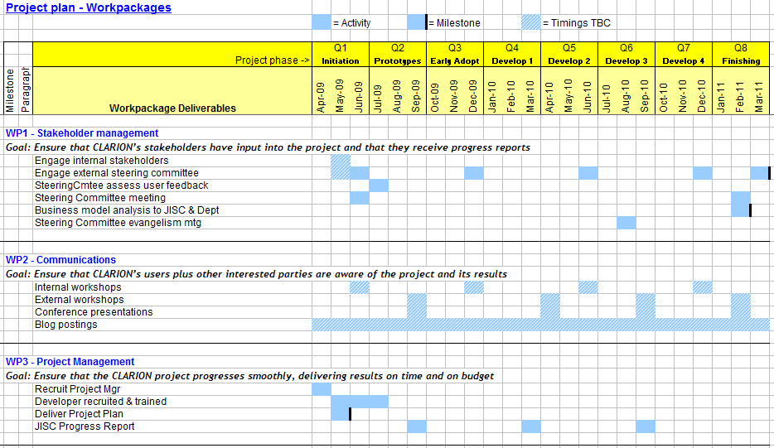
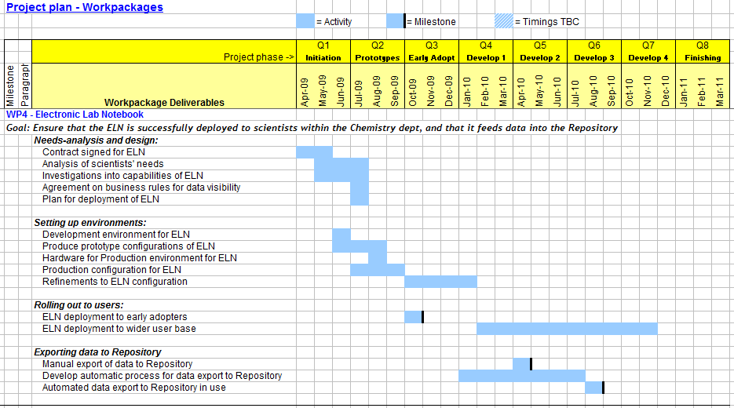
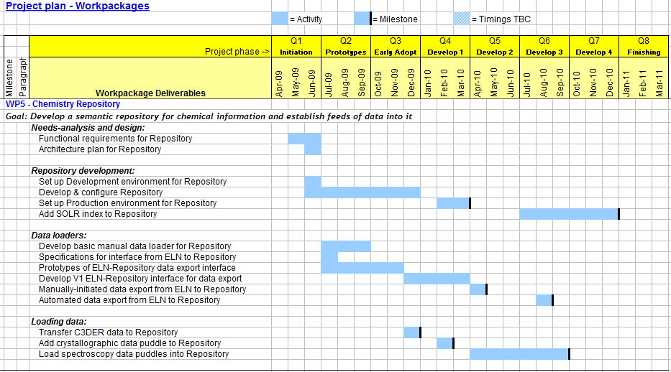
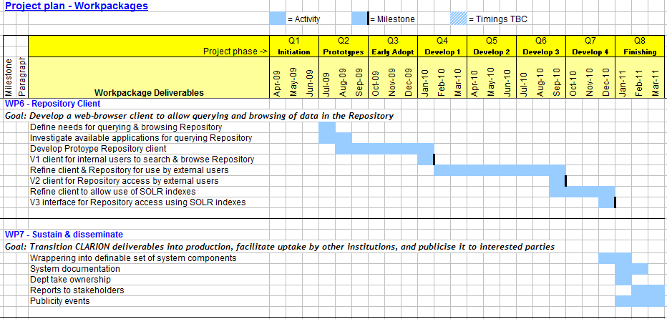

If the institutional contributions include a contribution towards the direct costs of the project please complete a table along the lines of the example overleaf

