Using block coupon



Table of contents

Prologue 3

Installation 4

(S)FTP 4

From within Moodle using the Moodle plugins directory 4

From within Moodle using the plugin installation upload page 4

Enabling the coupon plugin 5

Site page / home page 5

User dashboard / my page 6

Global configuration 7

Configuring background templates 8

Generating coupons for one or more courses 9

Step 1 9

Step 2 10

Step 3 10

Step 3-1 11

Step 3-2 13

Step 3-3 14

Generating coupons for cohorts 15

Generating coupons to extend access to course(s) 16

Allowing users to request coupon/voucher codes 17

Troubleshooting / common pitfalls 18

Document history

|  |  |  |  |
| --- | --- | --- | --- |
| Date | Author | Status | Description |
| 27-06-2018 | RJ van Dongen | V1 | Initial version |

# Prologue

This document describes the various possibilities and usage of the coupon block for Moodle.

The coupon block can be used to create vouchers that allows users to enroll into one or more courses by simply entering a voucher code. Hence, this *could* replace having to configure enrolments.

The purpose is to make it as easy as possible for users to enroll in your Moodle course(s).

Please do note the current version of this document is specifically intended for the Moodle 3.5 release of this plugin and onwards. This means some of the functionality as described in the following chapters might be unavailable for you if you run an older version. The interface has also been updated for the Moodle 3.5+ version of the plugin.

Functionally, the plugin has not changed, but the icons/images that are used in various parts of the plugin now refer to default Moodle icons instead of the custom ones. This choice has been made so the plugin fits better into the user interface of Moodle and/or the theme used.

# Installation

Installing the block is rather straightforward. The standard methods of installation are described below.

## (S)FTP

1. Download your needed release from our repository (<https://bitbucket.org/sebsoft/moodle-block_coupon/downloads/>) or from the plugin pages at Moodle (<https://moodle.org/plugins/block_coupon>).
2. Unzip the release on your computer
3. Login to your production server
4. Upload the contents of the source folder to the /blocks folder of your Moodle installation
5. Make sure the folder is named "coupon" (so you now have a folder /blocks/coupon)
6. Log in to your Moodle installation with administrative rights and go to the notification page
7. Moodle should now detect the coupon block can be installed.
8. Install the plugin
9. That's all

If you wish to update the block, please remove all old contents in the target folder /blocks/coupon, replace the source files and follow the steps 6 – 9 as described above.

## From within Moodle using the Moodle plugins directory

1. Login to Moodle with an administrative account
2. In the administration tree, navigate to the plugin installation page (Site administration -> Plugins -> Install plugins)
3. Click on the "Install plugins from the Moodle plugins directory" button. You will now be redirected to Moodle.org. You will have to login to moodle.org to be able to finish the steps below. Your site also should be registered to be able to use this possibility
4. Find the coupon plugin (use the searchbox to look for "coupon")
5. When you've landed on the coupon page, you should see a button "Install now"
6. Continue and choose the site you wish to install the plugin on
7. Click "Install now" for your website
8. Follow the steps as indicated by the automated process until you have successfully installed the plugin on your Moodle installation.
9. That's all

## From within Moodle using the plugin installation upload page

1. Go to <https://moodle.org/plugins>
2. Find the coupon plugin (use the searchbox to look for "coupon")
3. Download the correct version of the plugin for your moodle installation
4. Login to Moodle with an administrative account
5. In the administration tree, navigate to the plugin installation page (Site administration -> Plugins -> Install plugins)
6. Upload the downloaded source in the file uploaded. Do note: this option *could* be disabled by your system administrator.
7. Follow the steps as indicated by the automated process until you have successfully installed the plugin on your Moodle installation. In case any issues were found by the automated process, moodle will notify you about them.
8. That's all

# Enabling the coupon plugin

The coupon plugin can *only* be installed on the frontpage and/or the user dashboard. This makes sense since these are the most logical locations for any Moodle user to enter generated coupon/voucher codes.

## Site page / home page

To enable this plugin on the site home page, first make sure you have administrative rights.

Navigate to your site home page.

On this page, find the "Blocks editing on" button to make sure you can add blocks to this page.

Somewhere on this page you will now have a small block allowing you to add other blocks on the page. From the dropdown, select the "Coupon" option.

Moodle will now add the coupon block to this page.

**Important**: In the block, click on the configuration option to configure the block.

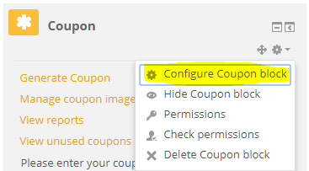

In the first section, choose either "Display on the front page only" or " Display on the front page and any pages added to the front page". This makes sure the plugin will be visible to all users on the site home page:

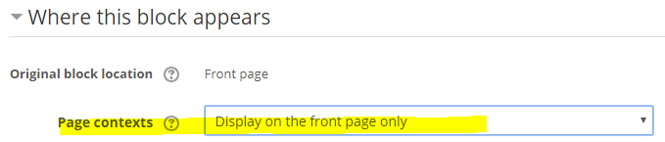

Save the changes and turn blocks editing off again.

Navigate to site home page to verify the block is visible there.

## User dashboard / my page

To enable this plugin on the user dashboard, first make sure you have administrative rights.

Using the administration tree, navigate to the page where you configure the standard dashboard page (Site administration -> Appearance -> Default Dashboard page)

On this page, find the "Blocks editing on" button to make sure you can add blocks to this page.

Somewhere on this page you will now have a small block allowing you to add other blocks on the page. From the dropdown, select the "Coupon" option.

Moodle will now add the coupon block to this page.

**Important**: In the block, click on the configuration option to configure the block.



In the first section, choose "Any page matching the above". This makes sure the plugin will be visible to all users on their Dashboard page:

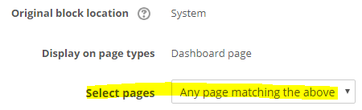

Save the changes and turn blocks editing off again.

Navigate to the normal user dashboard page (/my) to verify the block is visible there.

# Global configuration

To display the global settings page for the coupon plugin, use the administration tree to navigate there (Site administration -> Plugins -> Blocks -> Coupon).

There are various settings you should configure.

The most important settings here that you *should* configure are:

* Default role: you will *most likely* want to select "Student" here. The setting here will be used later when generating coupons/vouchers to pre-select the role to assign.
* Code length: This, by default, influences the generated voucher codes. Vouchers codes are a randomly *unique* code consisting of letters and numbers. For example: U94NusT.  
  This code is printed on the generated vouchers and is the code users will have to enter in the plugin to claim access and be enrolled in courses or cohorts.
* Maximum coupons: Because generating the coupons can be a *very* intensive process, it's wise *not* set the option here too high. The default of 50 is good enough.

*If* you wish to automatically clean unclaimed coupons after a certain period of time, you will want to enable the "Enable cleanup" option in the task settings. You should also configure the maximum age as per your needs/wishes. This setting is only used when automatic cleanup is *enabled*.

The alternative email settings will be used to pre-select the relevant options for you when generating the coupons later. More information on that will follow in the relevant sections later in this document.

# Configuring background templates

By default, the coupon plugin comes with a single image that will be used to provide a background for the PDF file(s) that will be generated for every coupon/voucher.

You may want to configure or use your own background to have a more personalized coupon that fits your needs. To manage one or more of these background images, navigate to the administration page in the plugin, using the "Manage coupon images" in the block:

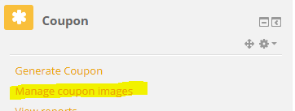

You will now be redirected to the correct page where you can simply add up to 10 custom backgrounds:

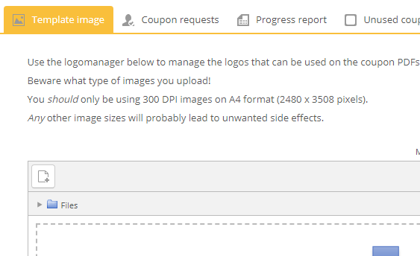

The interface fully supports drag/drop capabilities and will show any already existing images. Functionally, this is all "*standard Moodle*". The file manager you see is fully capable of also removing the images. If you're familiar with using the file manager in Moodle itself, you probably already know how to remove and/or manipulate the files. If you're not familiar with this interface: just click on any already existing image in the manager to manipulate the name, other (meta)information or delete the image.

# Generating coupons for one or more courses

Generating coupon/voucher codes for *courses* is not that hard and barely involves any extra configuration. In the coupon plugin, use the "Generate coupon" to navigate to the correct page:

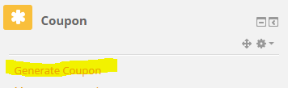

You will now be redirected to the most important part of the management pages: the possibility to create coupons:

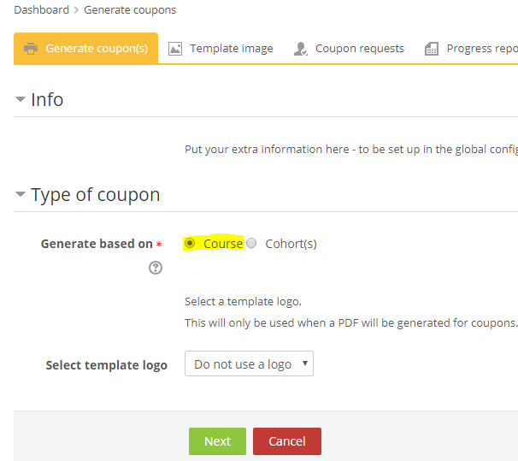

## Step 1

In the first "page" you will *have* to select the type of coupon/voucher you want to create. Since this section describes generating vouchers for *course* enrolment, you should select "course" (which is selected by default).

You can also select which background will be used to create your vouchers. In the "Select template logo" dropdown, please select the correct background image you want to use. You can choose not to use a background at all, but this will leave your PDF rather empty. If you haven't added any custom background (see chapter "Configuring background templates"), you only have the option to not use a background, or use the default one that comes with the installation of the plugin.

When you're done, click "Next"

## Step 2

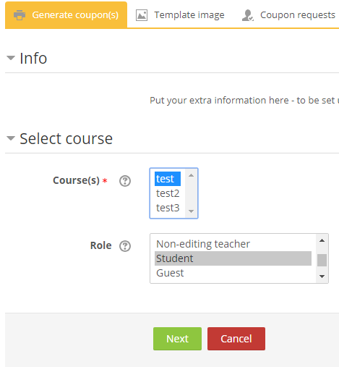

In step 2, you have to select one or more courses in which any user claiming the voucher will be enrolled. You will also need to select the role any user claiming the voucher will be assigned in the selected course(s).

When you've finished selected the course or courses *and* the correct role, please click "Next".

## Step 3

Thus far, the process has been pretty straightforward. But now comes a moment where you need to decide something important: do you wish to send the generated vouchers to specific *people* or do *you* wish to receive them so you can print them and hand them out?

Do note, this decision is rather important because it influences the process that follows after this step. You have 2 decisions really:

1. Generating coupons/vouchers that will be sent to you, or
2. Providing one or more users that the coupons/vouchers will be sent *to*.

If you chose the second option, whether the recipients have a Moodle account or not is of no relevance. More about that later.

## Step 3-1

We will assume here you chose the first option, which is " I want to create an arbitrary amount of coupons".

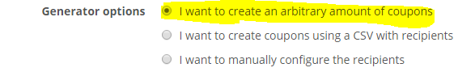

What follows, is the *mandatory* options you will have to configure:

1. Choose the number of vouchers/coupons you wish to generate in the "Amount of coupons" textbox. Enter any number greater than 0.
2. Select whether you want to use an alternative email address these vouchers/coupons will be sent to. *Note*: the default behavior of this checkbox is influenced by what you configured in your *Global settings* (See chapter "Global configuration").
3. If you chose to have the vouchers/coupons sent to an alternative e-mail address, you will *have* to enter a valid email address in the textbox for "Alternative email". *Note*: the default behavior of this checkbox is influenced by what you configured in your *Global settings* (See chapter "Global configuration").
4. Select whether you wish to create a PDF file for *every* generated voucher or not. It is *highly recommended* not to enable this. *If* you enable this setting and you chose a high number of vouchers to be created, you may never receive the email. See chapter "troubleshooting" for various reasons why this might happen.
5. Select whether you want a QR code included in every generated voucher/coupon PDF. Enabling this makes it easier to use the coupon, for instance to claim the coupon on devices that have the option to scan QR codes and act accordingly.
6. If you want a different landing page *after* a coupon has been claimed, you may want to manipulate the "redirect url". Normally a user will be redirected to their dashboard page, so unless you have specific reasons why you want to manipulate this, leave it as is.
7. Finally, *if* you want the claiming user to only be enrolled into the course(s) for a specific period, you should also configure the enrolment period. If you choose not to configure this specific option, any user claiming the coupon, thus being granted course access, will have an *indefinite* enrolment.
8. Click "Generate coupons" to process your request

For clarity, below is a screenshot of what you'd enter if you want to create 1 coupon for an already selected course named *test* with an enrolment duration of 7 weeks (note: from the moment the coupon is *claimed*). The generated coupon will be sent to a custom given email address and will include a QR code. When claimed, the claiming user will be redirected to their dashboard page in Moodle:

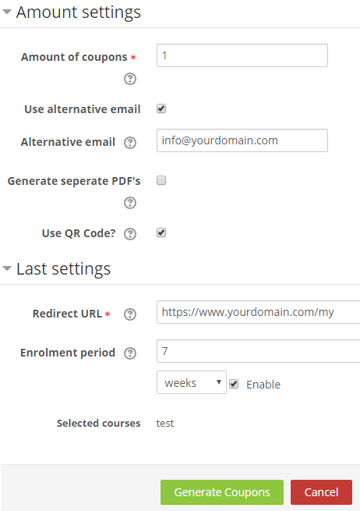

## Step 3-2

In this step, we will assume you want the generated coupon(s) to be sent *directly* to one or more users you will *have* to configure yourself. There are two ways of providing these users: either you upload a CSV file that contains the information, or you manually enter their details. Let's assume you'll upload a CSV file containing the information:

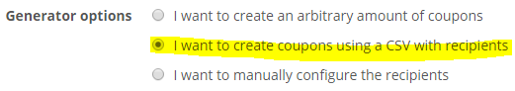

What follows, is the *mandatory* options you will have to configure:

1. Upload a CSV file containing the information for the users that will receive a voucher. Note: every given user will be sent *one* PDF that contains a voucher code. An example CSV file can be downloaded from this page, so I will not get into details on the contents. *Do note however, the first line of the CSV must always contain the field order of the CSV, and must contain the fields "E-mail", "Gender" and "Name".*
2. Enter the contents of the email that every given user will receive. A standard message is given, you can modify it to your needs.
3. Enter / change the date at which the vouchers/coupons will be sent
4. If you want a different landing page *after* a coupon has been claimed, you may want to manipulate the "redirect url". Normally a user will be redirected to their dashboard page, so unless you have specific reasons why you want to manipulate this, leave it as is.
5. Finally, *if* you want the claiming user to only be enrolled into the course(s) for a specific period, you should also configure the enrolment period. If you choose not to configure this specific option, any user claiming the coupon, thus being granted course access, will have an *indefinite* enrolment.
6. Click "Generate coupons" to process your request

## Step 3-3

In this step, we will assume you want the generated coupon(s) to be sent *directly* to one or more users you will *have* to configure yourself. There are two ways of providing these users: either you upload a CSV file that contains the information, or you manually enter their details. Let's assume you'll configure the recipients yourself:

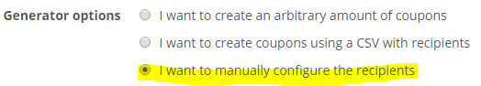

What follows, is the *mandatory* options you will have to configure:

1. Enter the email address, gender and name of the recipient(s), each on a new line*.*
2. Enter the contents of the email that every given user will receive. A standard message is given, you can modify it to your needs.
3. Enter / change the date at which the vouchers/coupons will be sent
4. If you want a different landing page *after* a coupon has been claimed, you may want to manipulate the "redirect url". Normally a user will be redirected to their dashboard page, so unless you have specific reasons why you want to manipulate this, leave it as is.
5. Finally, *if* you want the claiming user to only be enrolled into the course(s) for a specific period, you should also configure the enrolment period. If you choose not to configure this specific option, any user claiming the coupon, thus being granted course access, will have an *indefinite* enrolment.
6. Click "Generate coupons" to process your request

For clarity, below is a screenshot of what you'd enter in the recipients field if you want to create coupons that will be sent to two users (John and Jane Doe):

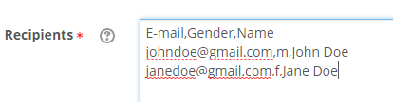

# Generating coupons for cohorts

This section has not been written yet and will be finished in a next version of the document.

# Generating coupons to extend access to course(s)

This section has not been written yet and will be finished in a next version of the document.

# Allowing users to request coupon/voucher codes

This section has not been written yet and will be finished in a next version of the document.

# Troubleshooting / common pitfalls

This section has not been written yet and will be finished in a next version of the document.