SUNY Mapper
SUNY Mapper Manual
CSC436/446 - Professor Warren

Project Manager – Simon Ventura

Developer - Matt Iglody

Design – Eric Dustin

Design – Ryan Pulsifer

Documentation - Jessica Paradise

Documentation – Kristen Eastman

Testing – Clinton DeMerritt

Original Plan Date: January 28, 2013

Expected Completion Date: May 17, 2013

About this Document -SUNY MaPPER MANUAL
"Team Map" has been working for the last couple months on a product that will allow new people to the SUNY Plattsburgh campus to have an easy way of navigating through the Redcay building. Our mission was to create an application that would allow people of all different ages and backgrounds to have an easy and convenient way to get directions from one room in the building to another. The way we, as a team, decided would be best to implement this type of application would be to make an iPhone app. This proved to be more difficult than we thought. This manual will tell the story of the journey that we have taken to get to the final product that we are about to release to the public and a guide how to use the SUNY Mapper application to its full potential.

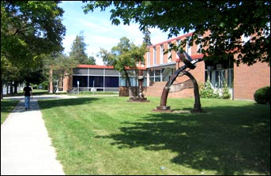

tools and resources
Our Developer Matt is using DragonFireSDK and according to DragonFireSDK.com “is the world’ first C/C++ iPhone Library for Visual Studio.” Matt is using Visual Studio ’08. With the help of DragonFireSDK, he is able to program the iPhone App in Windows.
Ryan, a member of our Design team created a visual display of what we would like our app to do(as far as how we would want the directions to be show to the user.) He created this visual demonstration in Python. This can be found in the Downloads as a zip file called “SUNYMapper_PythonBFSdemo.”

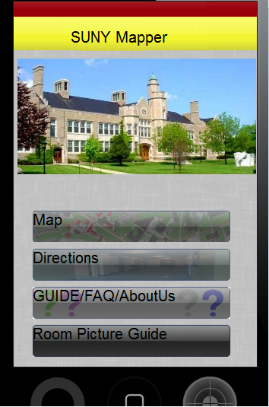
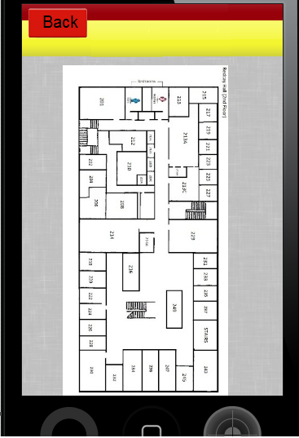
user guide
How to use:
When you open the application, it brings you to the ‘Main Menu’ screen. Here you can choose from: ‘Map’, ‘Directions’, ‘GUIDE/FAQ/AboutUs’, and ‘Exit’. →
Each icon brings you to the different aspects of the App. The following instructions give you a detailed look at how to use this application and each icon.
-First, for the purpose of this User Guide,- click on the icon that says: ‘Map’.

← Using the ‘Map’:
This button shows you an image of the floor plan of the building and floor in which you want to see. (In the current version, the only floor plan available is the second floor in Redcay.) You have the ability here to look at the room numbers available to search for in the ‘Directions’ button as well as to find your own way to get to where you’d like to go.

-Now, return back to the main menu screen by clicking on the ‘Back to Home Screen’ icon at the bottom- of the screen. When you get back to the main menu, click on the ‘Directions’ icon.
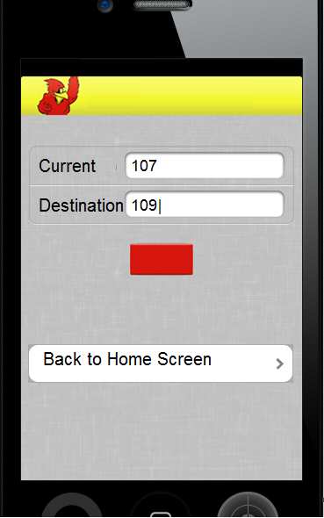
Using the ‘Directions’:
This part of the application helps you by giving you a path to follow on the map. Here’s how to use this part:
← The screen that opens should look like the screen you see to the left.
  - Enter in the room number that you are currently in or near in the ‘Current’ box.
  - Enter in the room number that you wish to get directions to in the ‘Destination’ box.
  - Click on the red box underneath to get your directions.
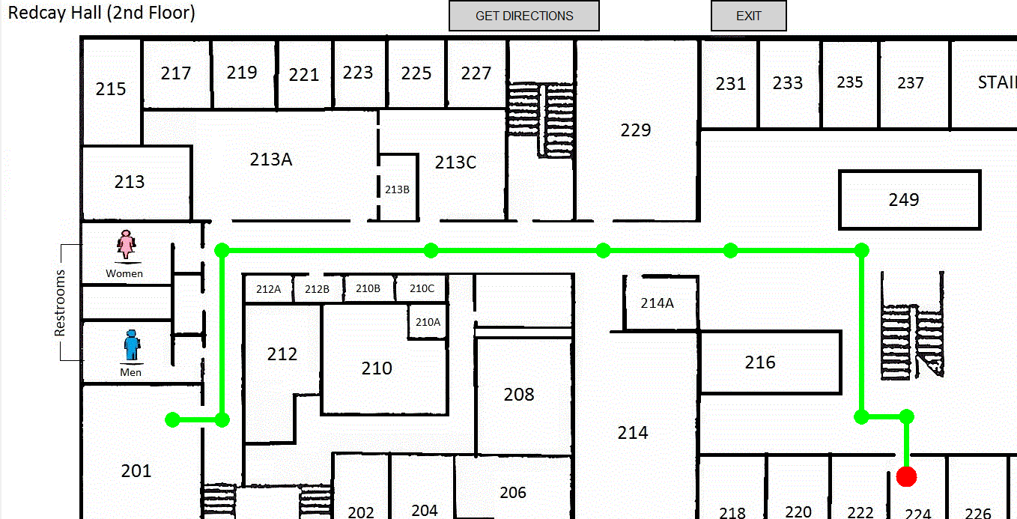
The app should then bring you to a screen that may look like this:
The line on the map → gives you a path to follow to get you to where you need to go.

- After you’ve taken a look at the map, exit back to the directions screen and click on the ‘Back to - Home Screen’ icon. When you’ve returned to the Main Menu screen, click on the icon that says ‘GUIDE/FAQ/AboutUs’.

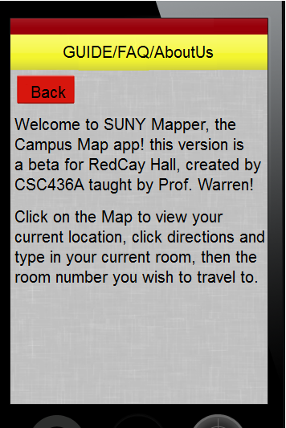
Using the ‘GUIDE/FAQ/AboutUs’: →
This section will give you information about the app, as well as Frequently Asked Questions, and information about the creators of this application. Here you have the ability to read through and find out any questions you may have, as well as learn more about the SUNY Mapper app.

-When finished taking a look at the User Guide and FAQ’s,- return back to the Main Menu and use the app at your leisure. To Exit, click on the ‘Exit’ icon at the bottom of the Main Menu. Thank you for using the SUNY Mapper application!

(Below you will find some common frequently asked questions.)

faq

Are there any OS requirements that I need in order to use the app?
Yes, you will need an iPhone OS, internet connection, and a web browser available.

How do I start using the SUNY Mapper app?
Go to the main menu and choose within the menu with option you would like to go to, then the app will bring you to that option and start working!

Where do I type in the room I want to go to?
On the main menu, click on “Directions”, there you will be prompted to enter where you need to go.

Will the directions give me a step-by-step way to go?
No, not at this point in time, the application only offers a map with a line that gives you a route to follow.

Can I look at an overlooking map of the building that I am in without typing in where I want to go?
Yes. Go to the main menu, and click on the “Map” icon, this should bring you to an overlooking map of what building you are currently in.

How do I search or get help if I can’t find my question here?
On the menu screen, there will be an icon, “Help”, to click on that will bring you to an information screen that gives you the correct phone number and e-mail address where you will be able to reach someone with the answers you are hopefully looking for.

How do I exit?
On the main menu screen, there is an icon that says “Exit”. This will allow you to exit the application.

What do I do if my app doesn’t work right on my phone?
Try uninstalling the app from your phone and then restarting the device. When the device turns back on, go back and try installing the app again. If that doesn’t work and the problem persists, see the “Help” icon for further assistance.

Can I save the directions that the map gives me for future assistance?
The app doesn’t have its own “Save” button, but one way you could save what you see on the screen is to take a “screenshot” with your device; varies per device.

How can I tell the app my current location?
You can either turn your ‘GPS on’ on your phone, and the app should automatically find where you are. Or you can also type in your current location when you go to the “Directions” icon on the main menu into ‘Point A’.

How do I start a new request for directions?
Just return to the main menu and click on “Directions” again. While there, your previous direction list will have already been erased, or you will be able to hit the icon “New Directions” at the bottom of the screen.

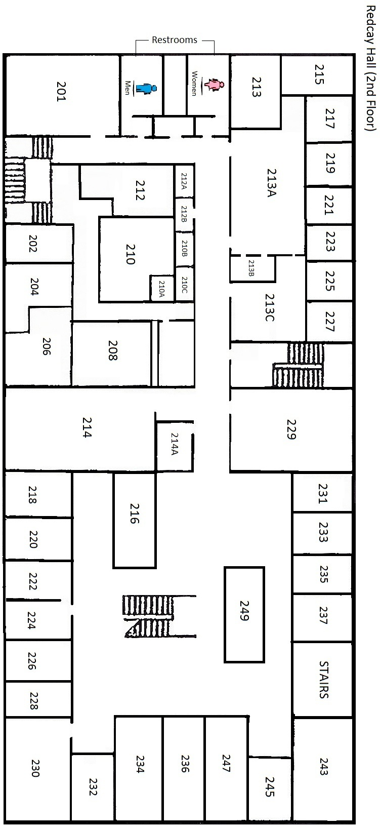
*Note - Picture is not to scale. This is meant to be used as a reference. This map is the one that was used to create the direction part of the application.
