https://autotestingtools.atlassian.net/wiki/spaces/UFB/overview

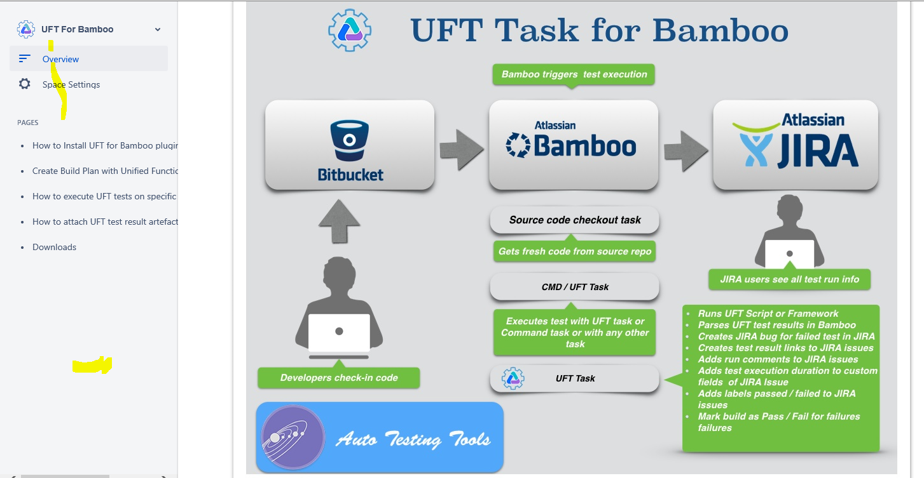

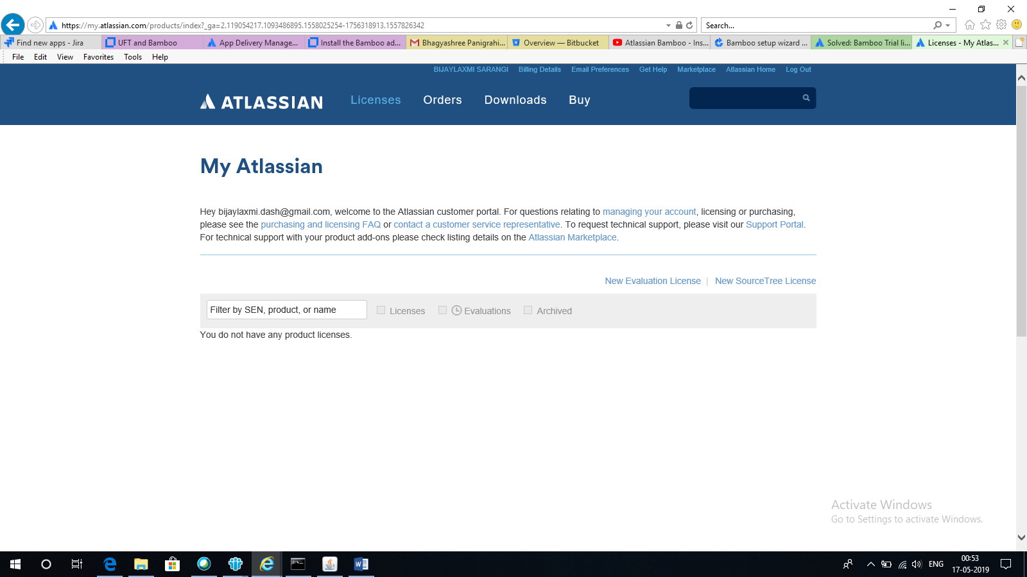

New Evaluation License

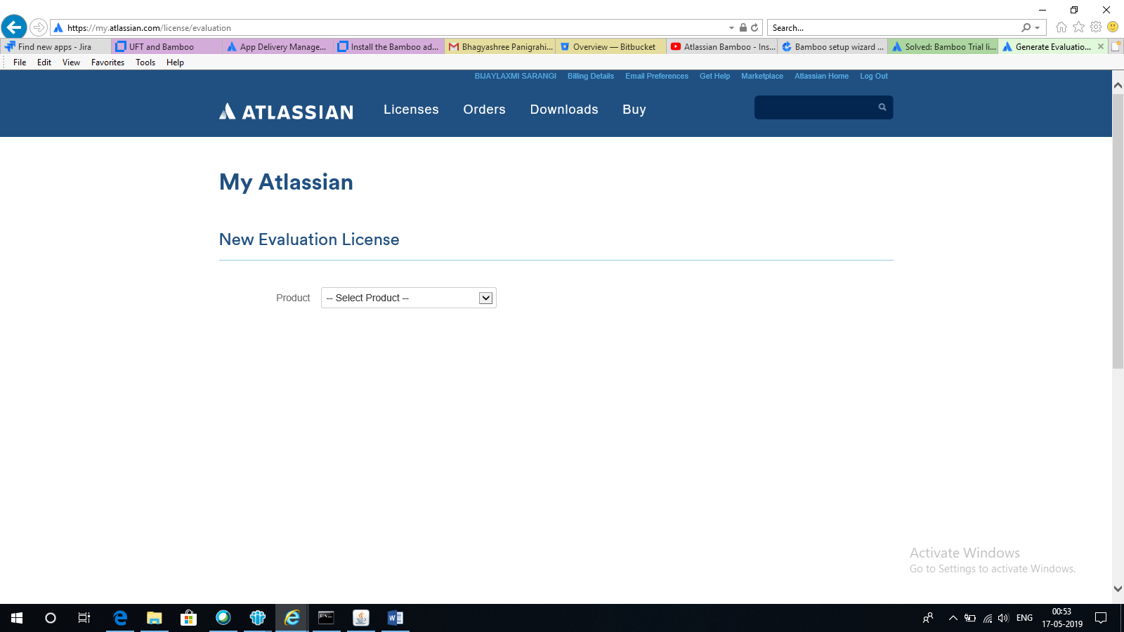

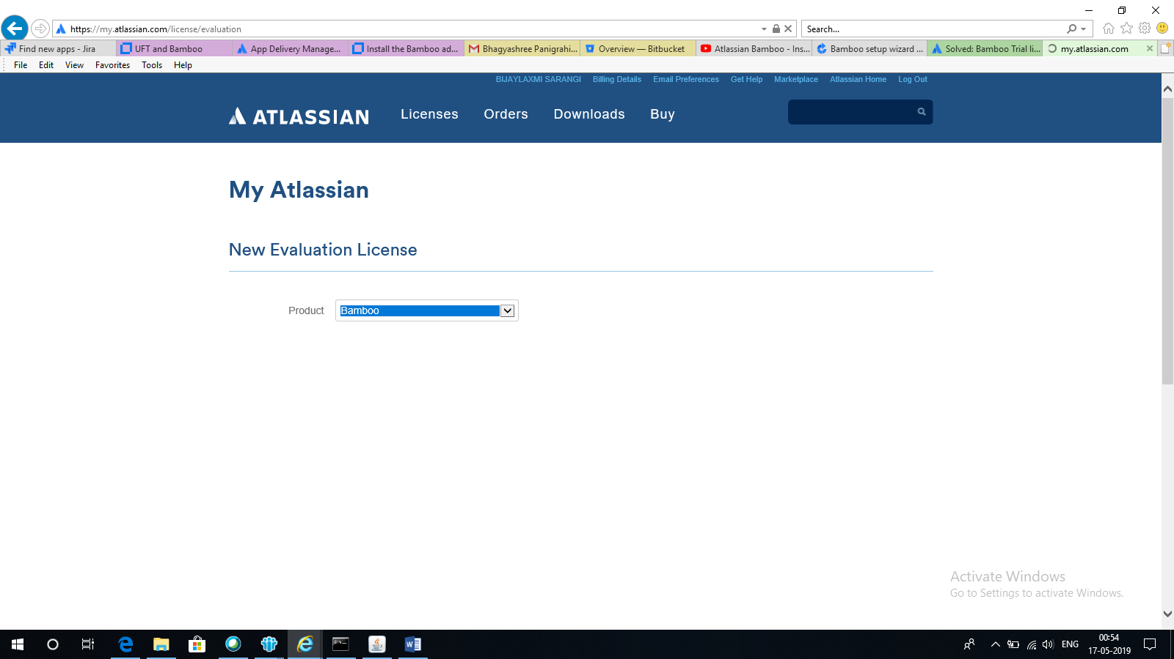

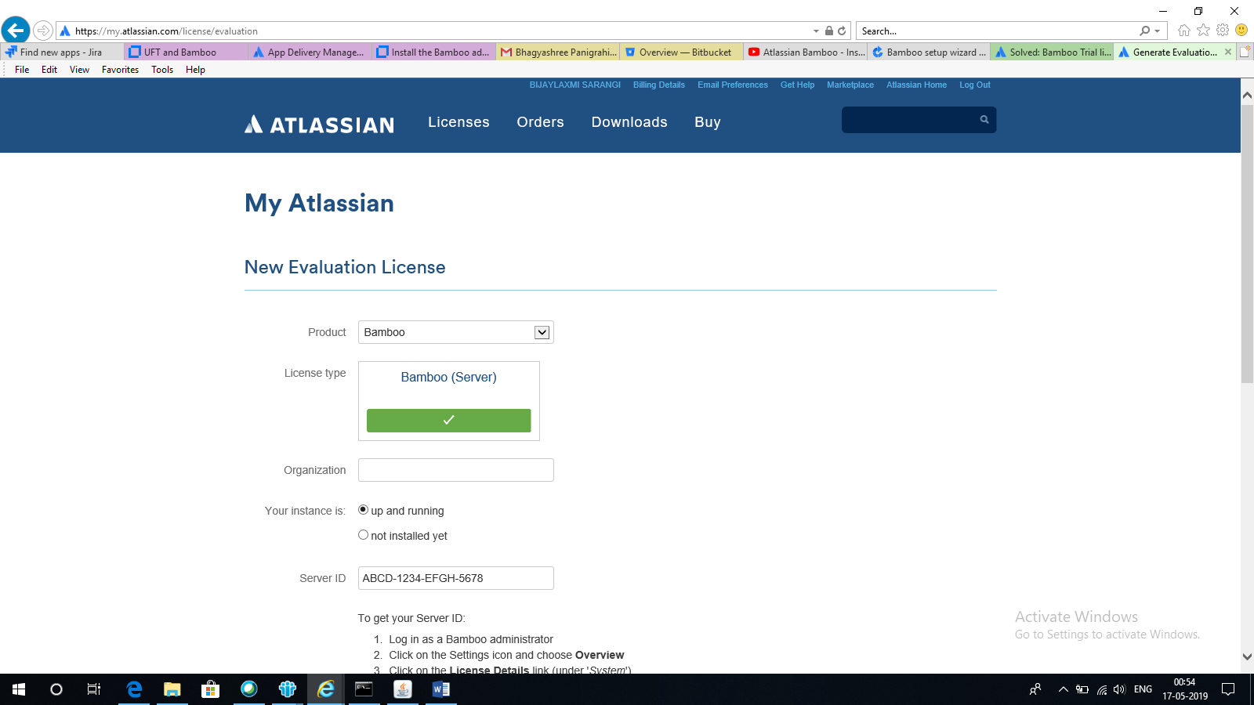

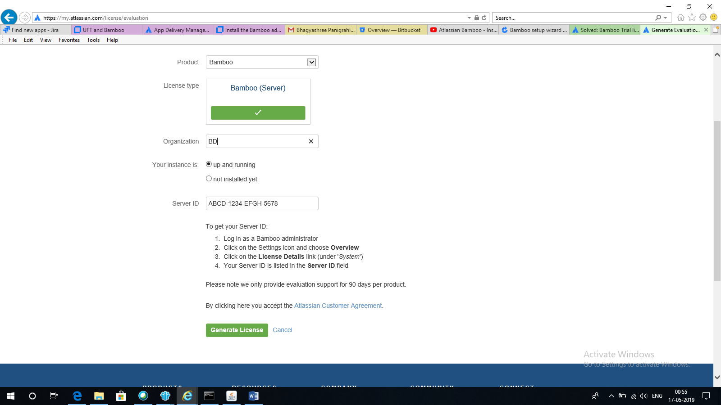

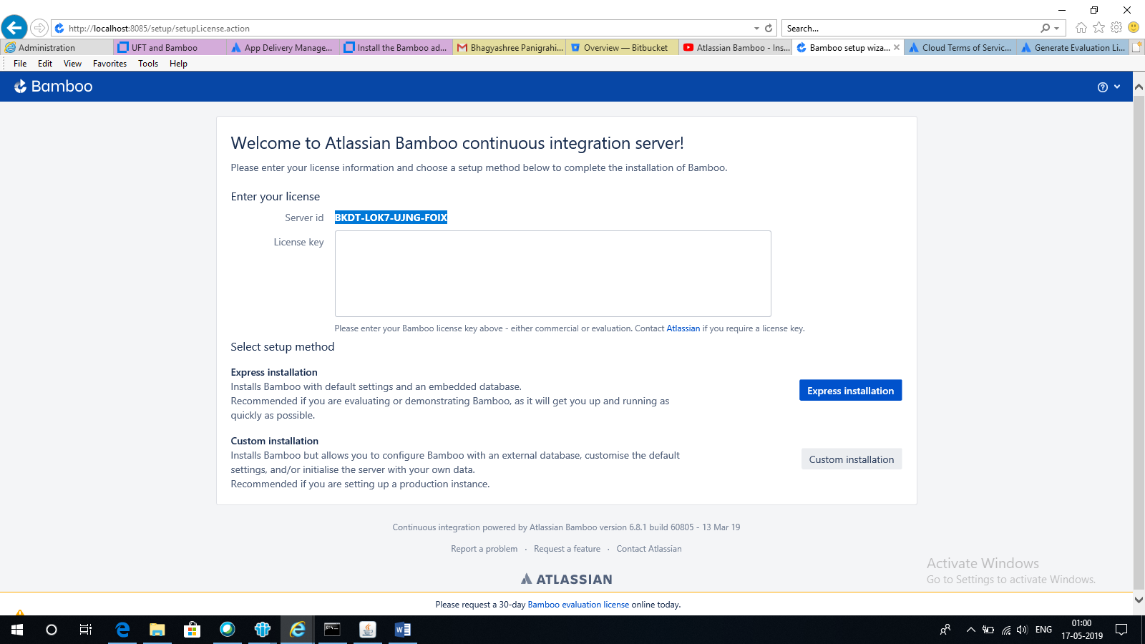

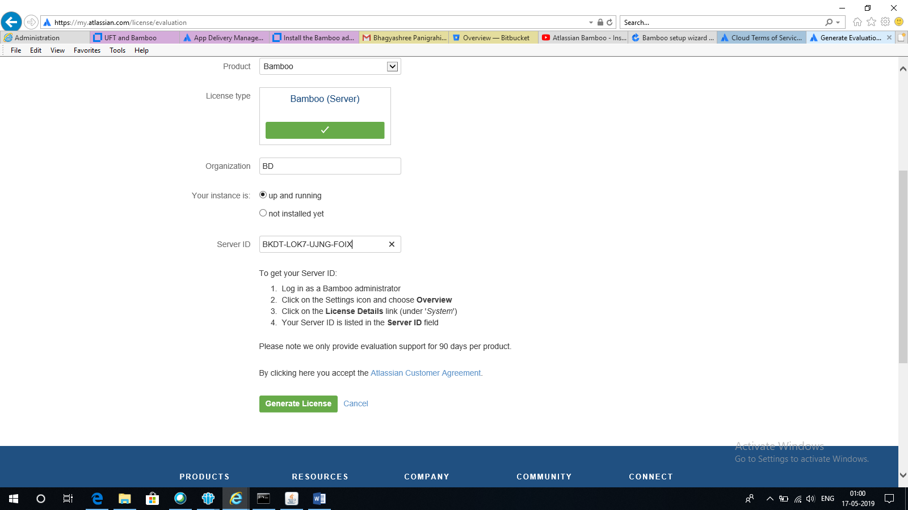

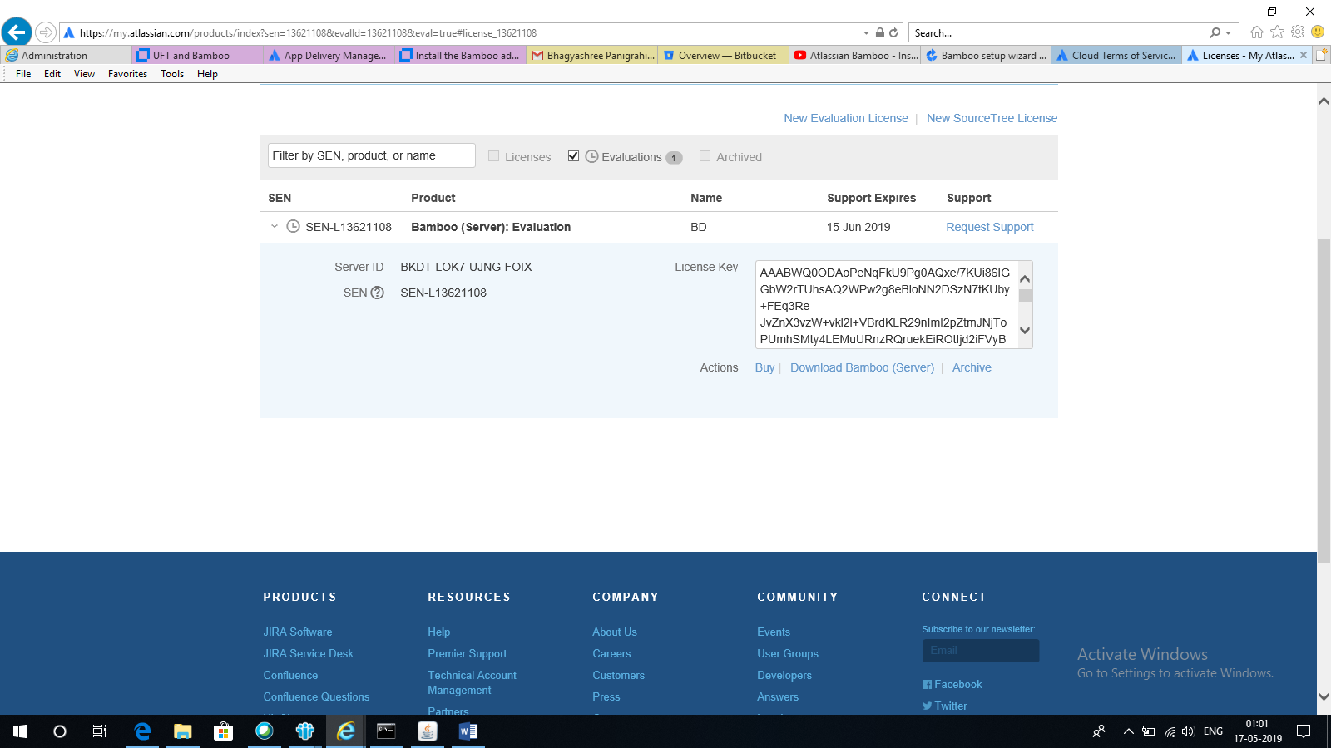

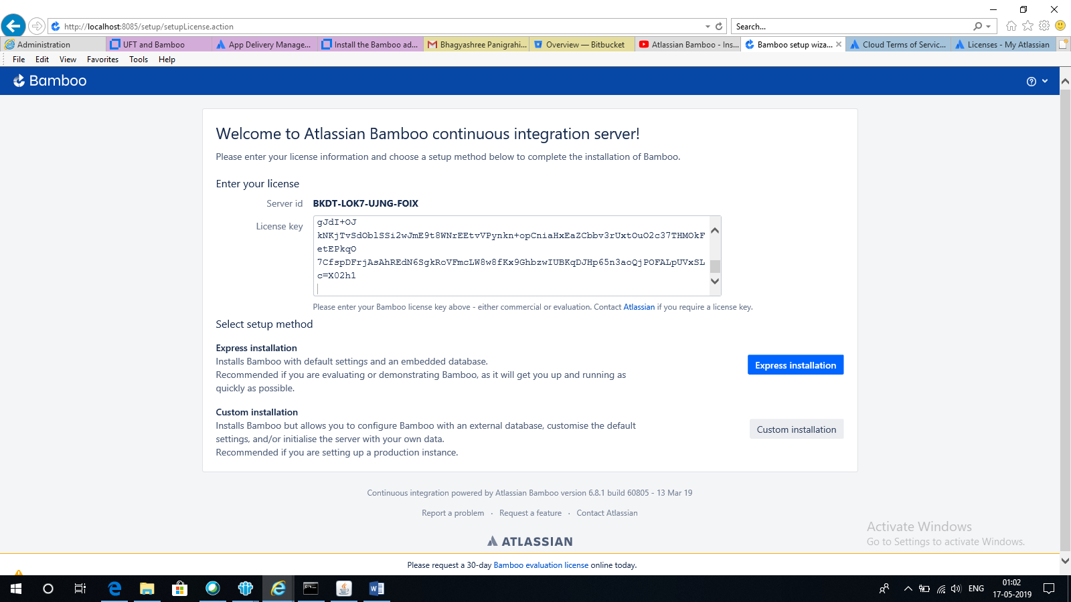

Express Installation

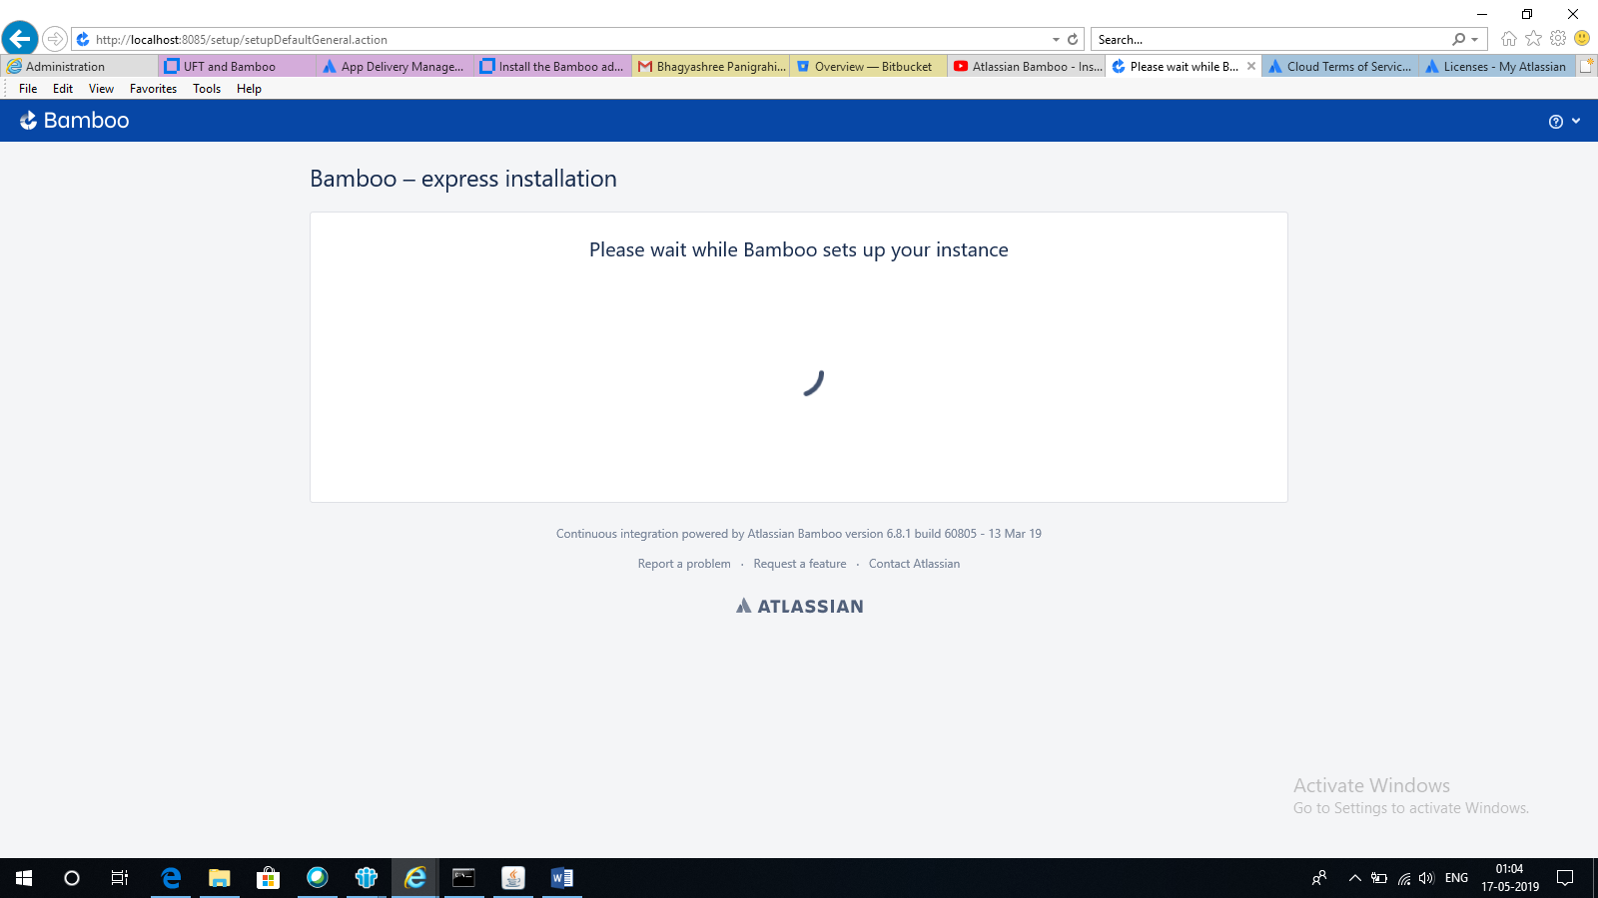

BN0X-UUBH-4S3C-PKXF

AAABWQ0ODAoPeNqFkU9vgkAQxe/7KUh6aQ8YFlsNJiSVP6akgAS08dDLgKNuA4tZFlO+fREkrY1Nb

zO7s++9+e3dQjAlgEahU0WjMzqdUUOxnZWia9QgKRRpWY58liGv0N0yyUpuuuHKjaPYS1xil1xCJ

kMo0EzZBzQ5fBZstIXq8LwvgOWjrCwGmbAuUhTLndW1fplBPt8jl5WpUhLVIjtAhQ5INM/mqvak0

ikZvD+PTDQ/LicqnQz2btA6/e/fTrITmlLUSBIUJxSeY1qhtlHXa+tFfUzGthq9bha388ZYlBIvg

ammabfHohx4t9A1u1VzxI6SvQwCN7a9uU/a1FwiB579sd5FIpEgJApzB3mFA5A2uu85iRuqPh1Pd

N0wdNJ25vXJUuyBswq6f7McYgvs6t+U8170DUV1ntSJg1Um2LF/18VQ7ntmD+8zxT1BXndC5Lvsw

X4BcajFkjAsAhRUc4umkOFSELH/lAMloPPUFkR/XQIUDy4ckJZ/1G+ti0GhFpJLdWyb3gI=X02h1

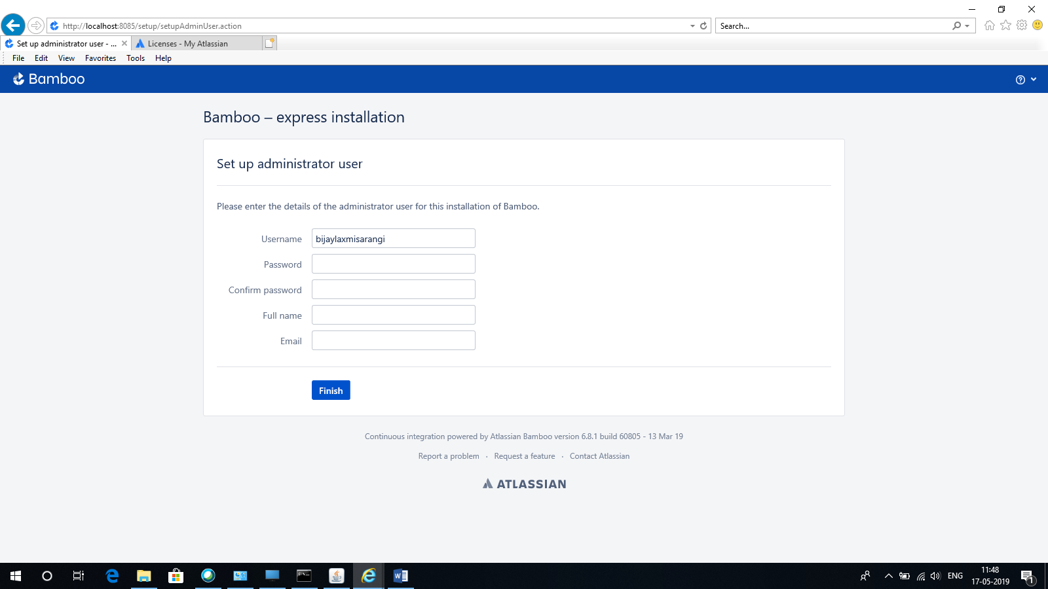

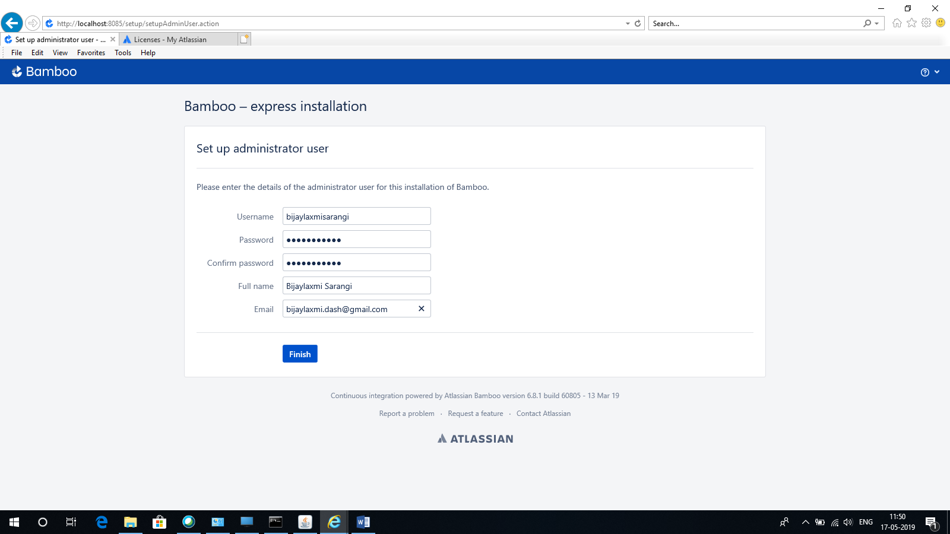

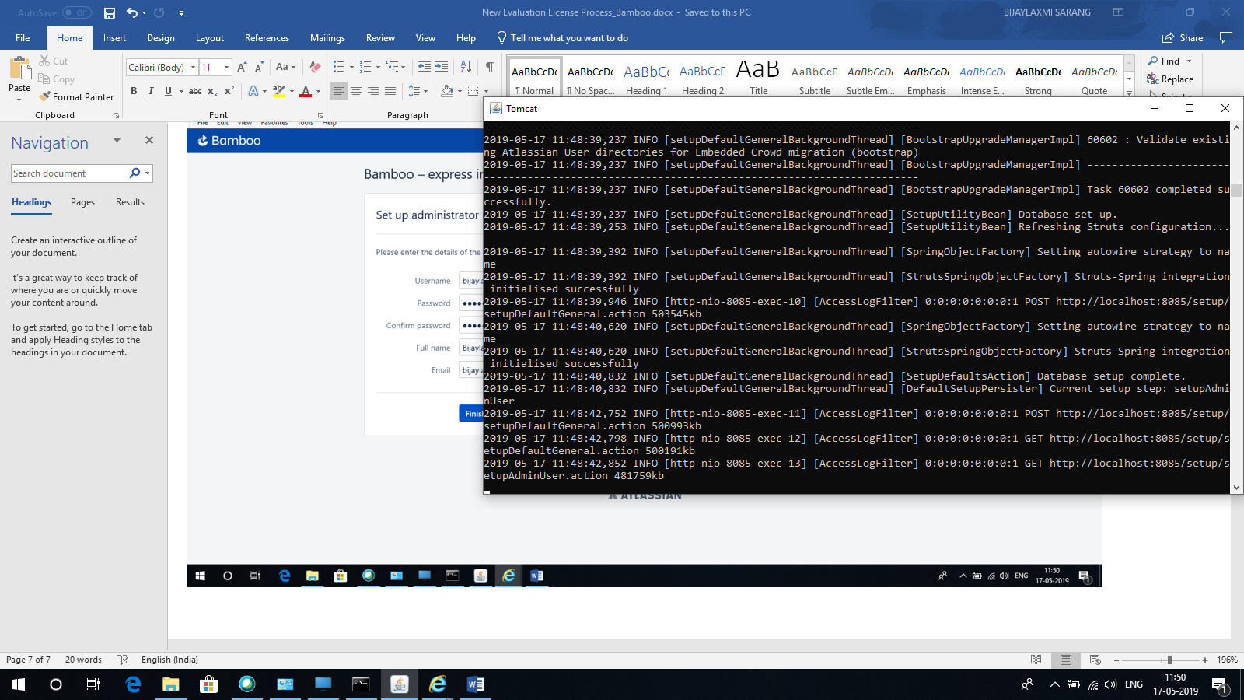

Finish

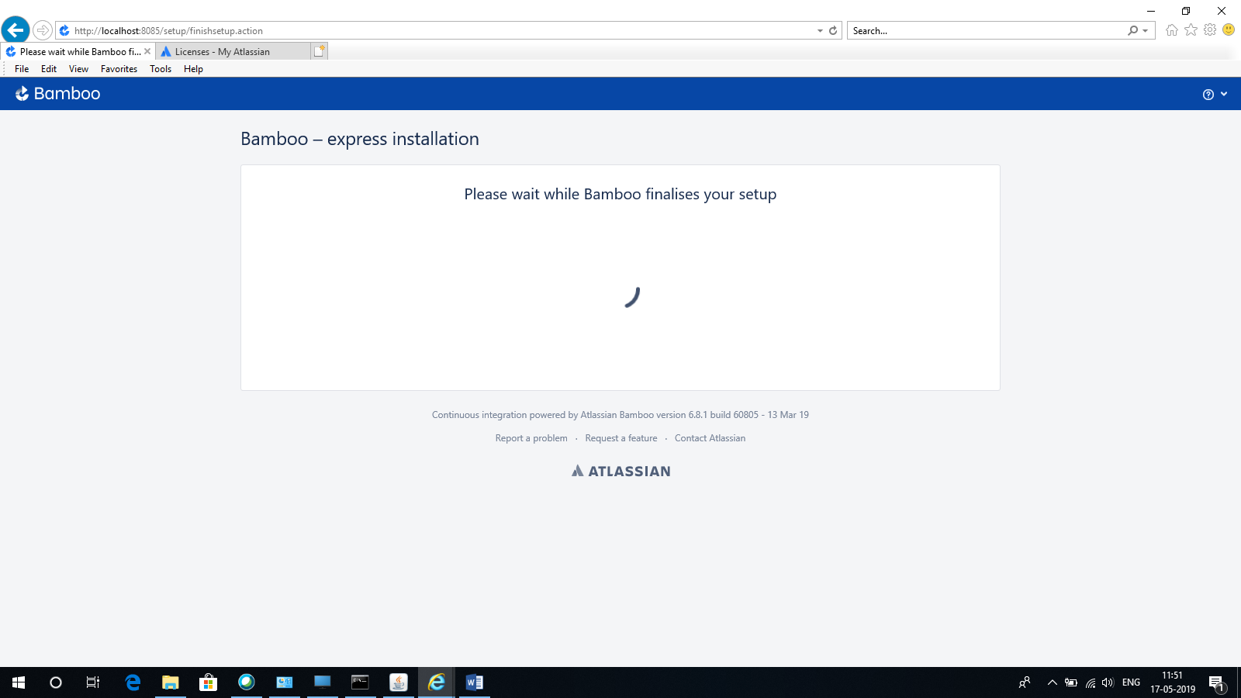

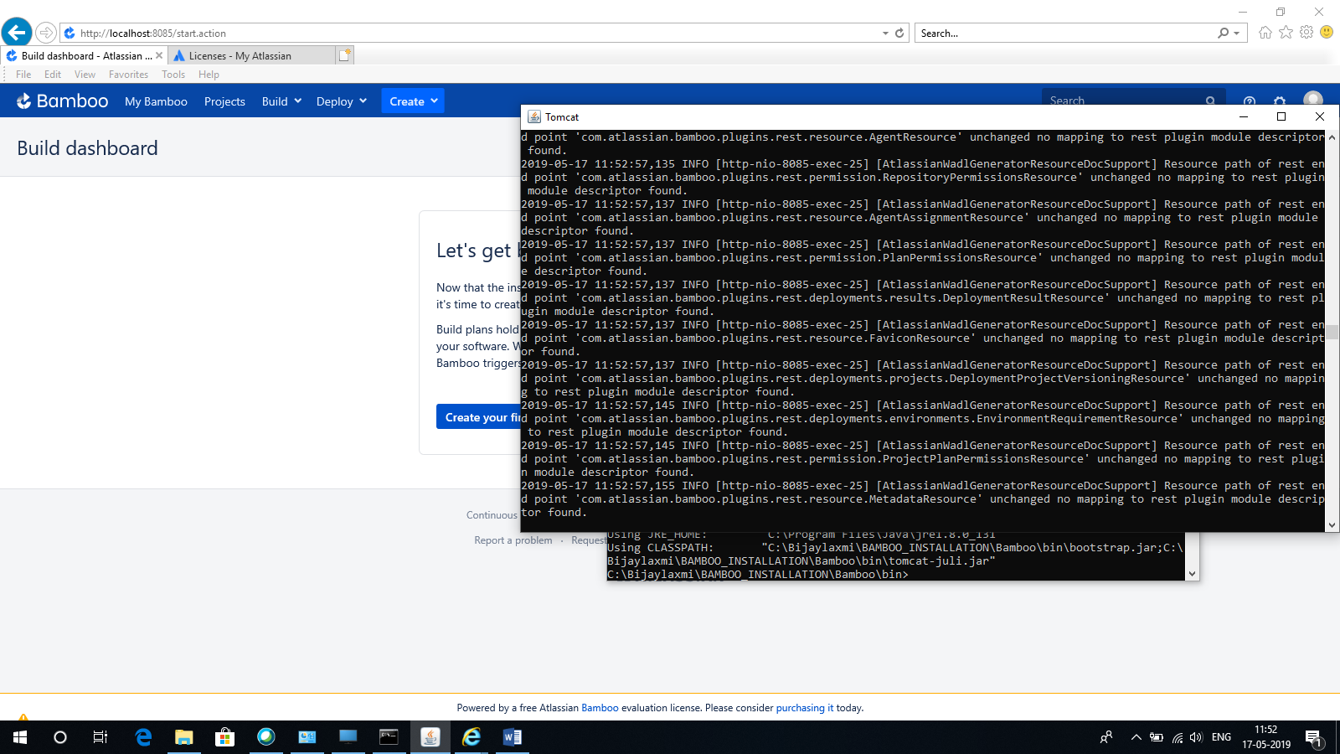

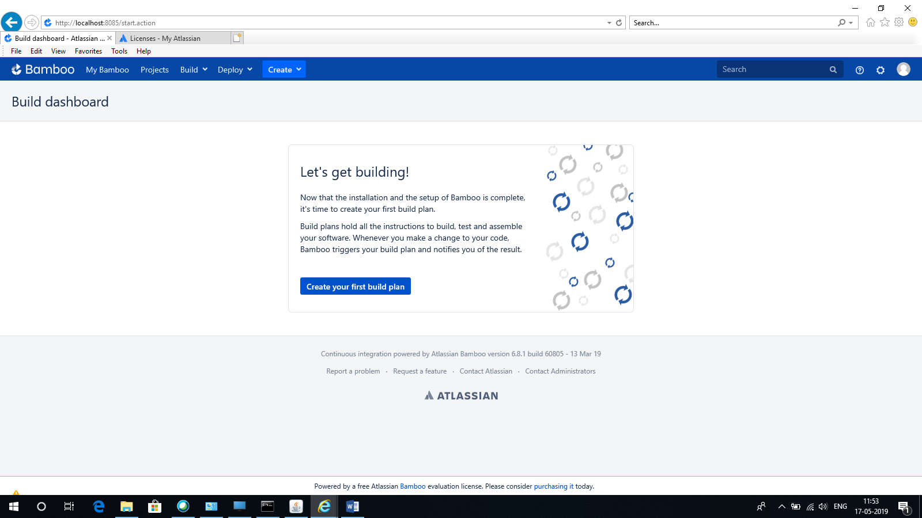

Create your first build plan

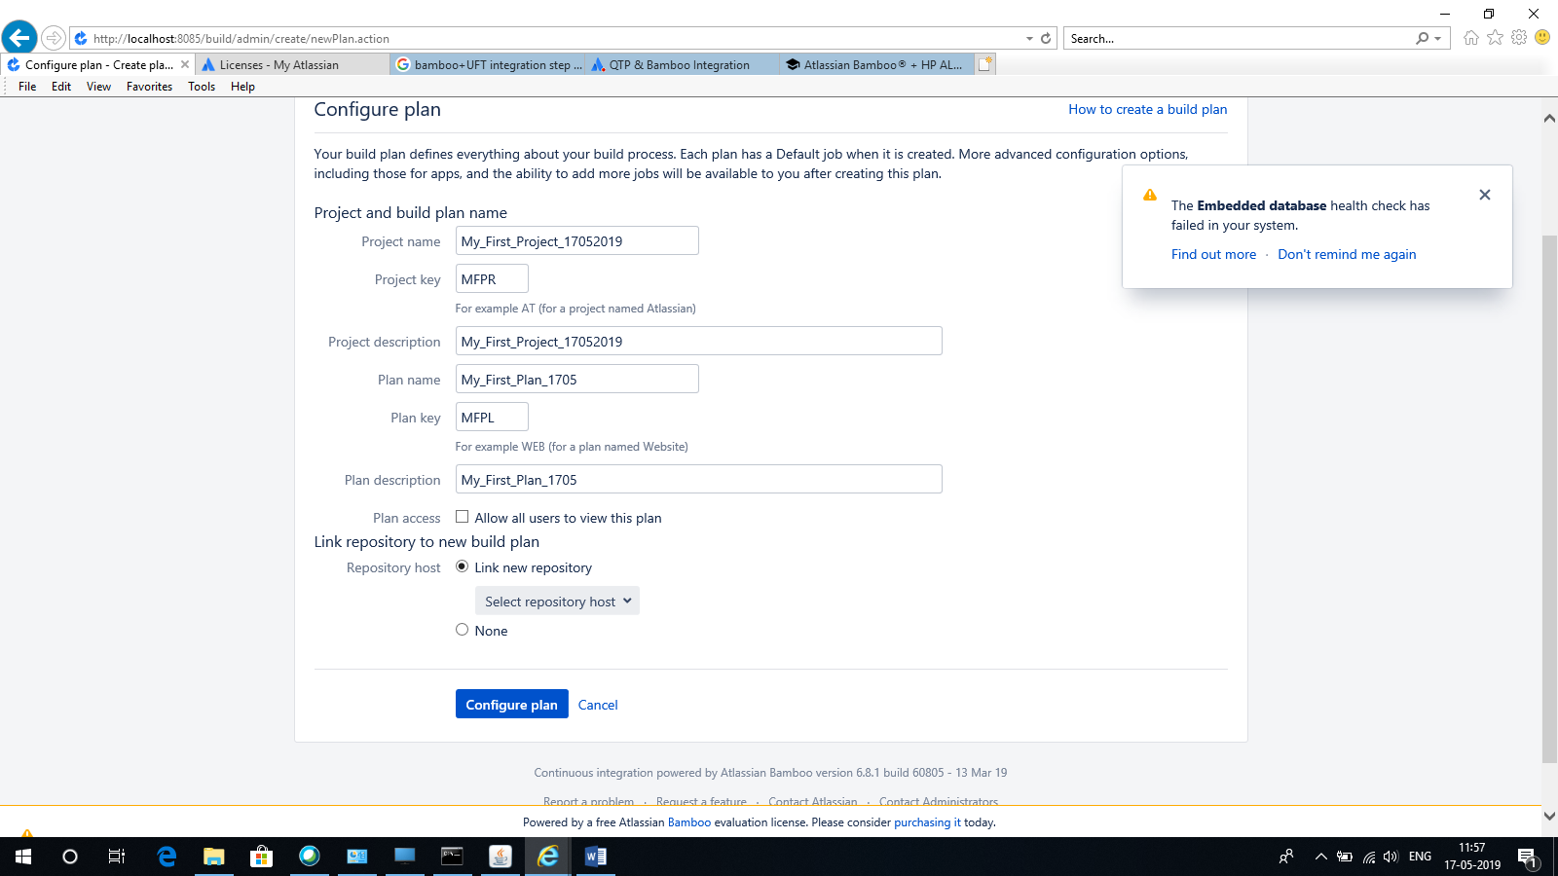

How to Install UFT for Bamboo plugin

Created by [Vikas Borse](https://autotestingtools.atlassian.net/people/557058:e54f9c0b-efaa-4f0d-be28-cf33e45c95af?ref=confluence&src=profilecard)

Last updated [Jan 14, 2017](https://autotestingtools.atlassian.net/wiki/pages/diffpagesbyversion.action?pageId=1442031&selectedPageVersions=3&selectedPageVersions=4)

**Installation**

1. Log into your Bamboo instance as an admin.
2. Click the admin dropdown and choose **Atlassian Marketplace**.The *Manage add-ons* screen loads.
3. Click **Find new add-ons** from the left-hand side of the page.
4. Locate **UFT Task for Bamboo** via search.The appropriate add-on version appears in the search results.
5. Click **Try free** to begin a new trial or **Buy now** to purchase a license for **UFT Task for Bamboo**.You're prompted to log into MyAtlassian. UFT Task for Bamboo begins to download.
6. Enter your information and click **Generate license** when redirected to MyAtlassian.
7. Click **Apply license**.If you're using an older version of UPM, you can copy and paste the license into your Bamboo instance.

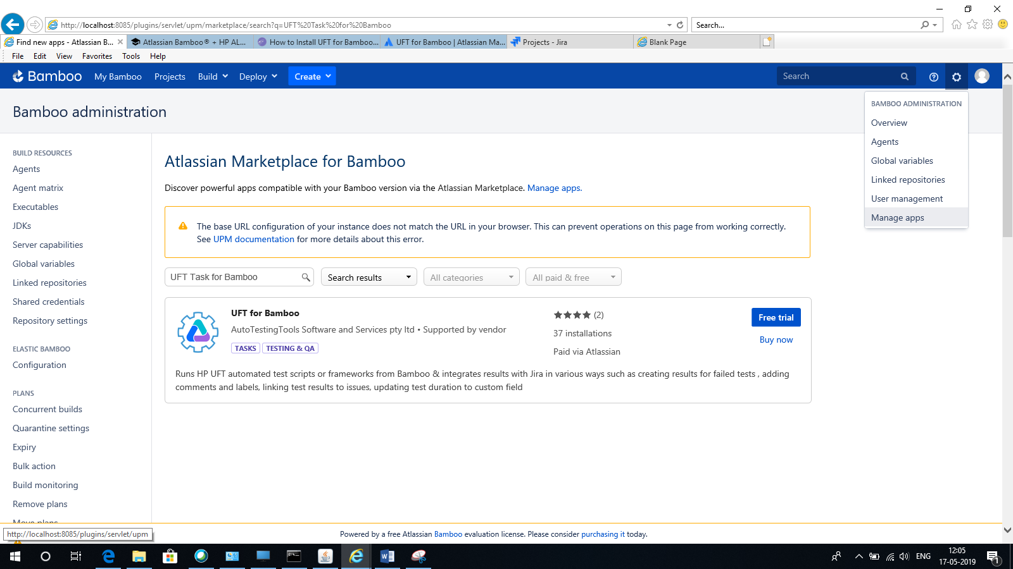

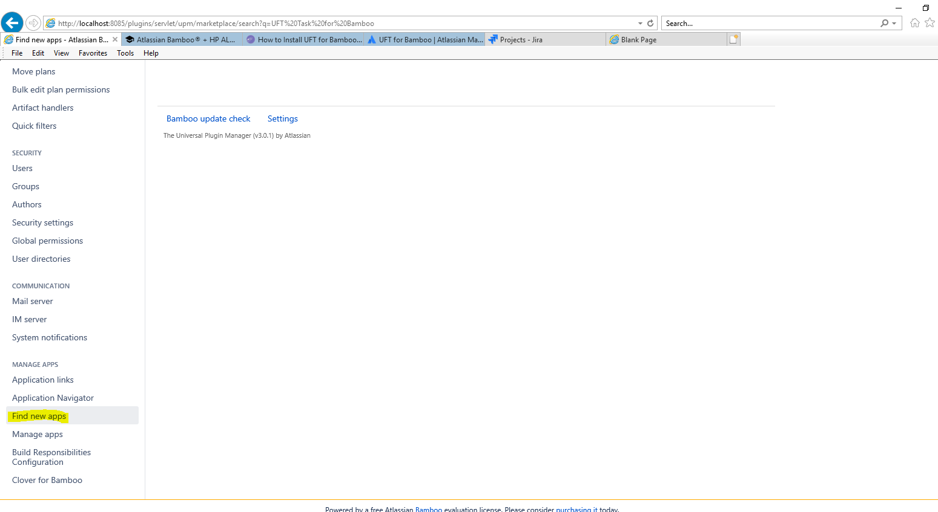

Free Trial

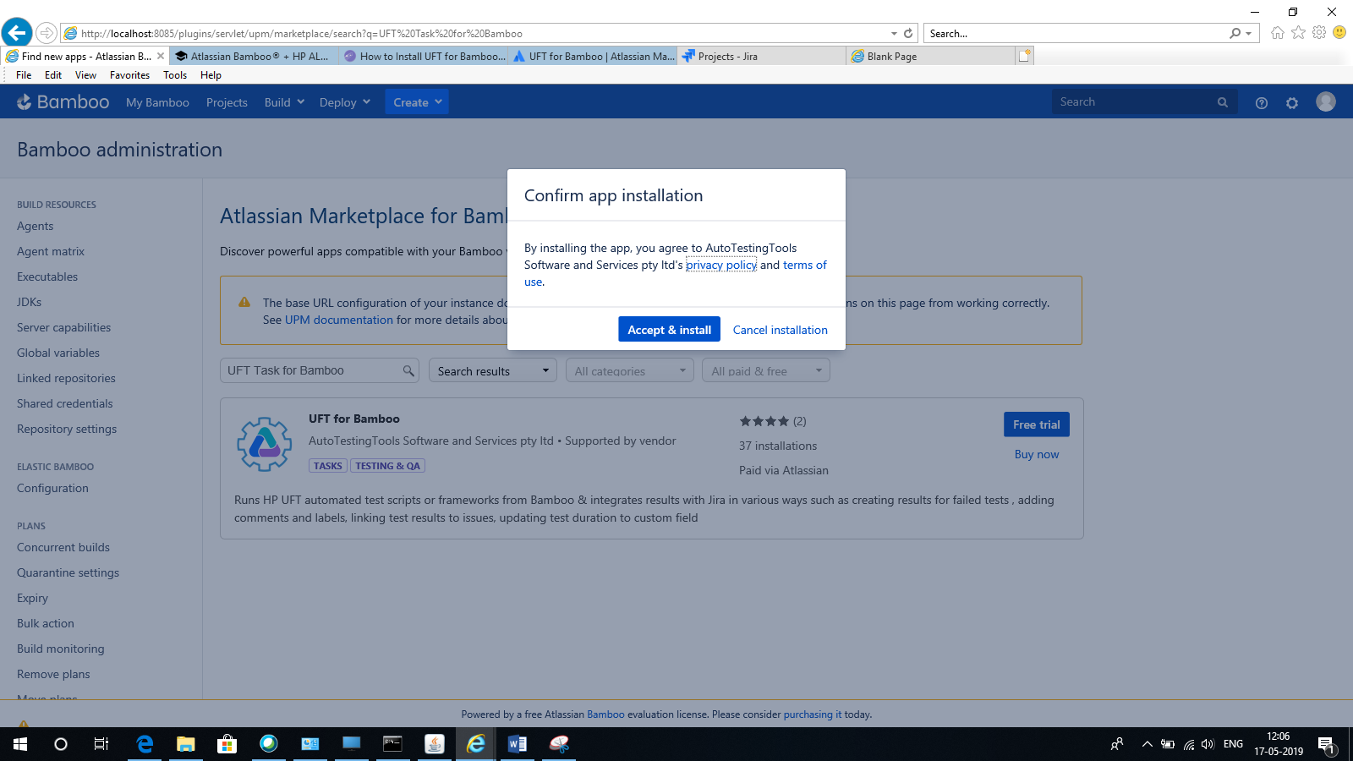

Accept & Install

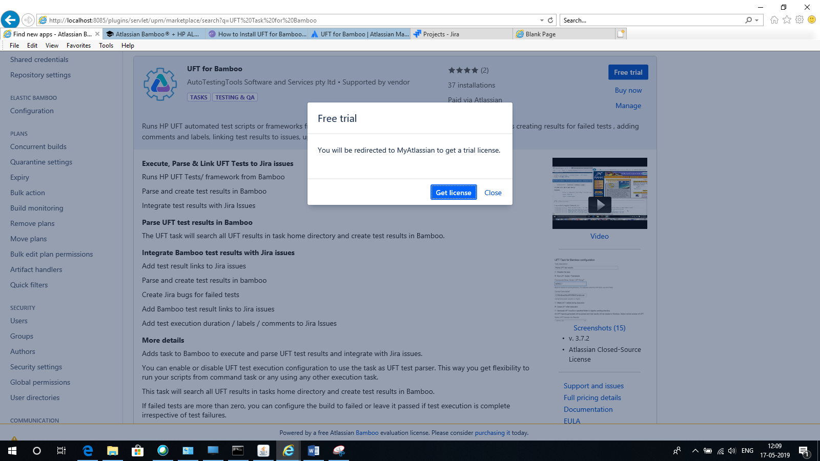

Get License

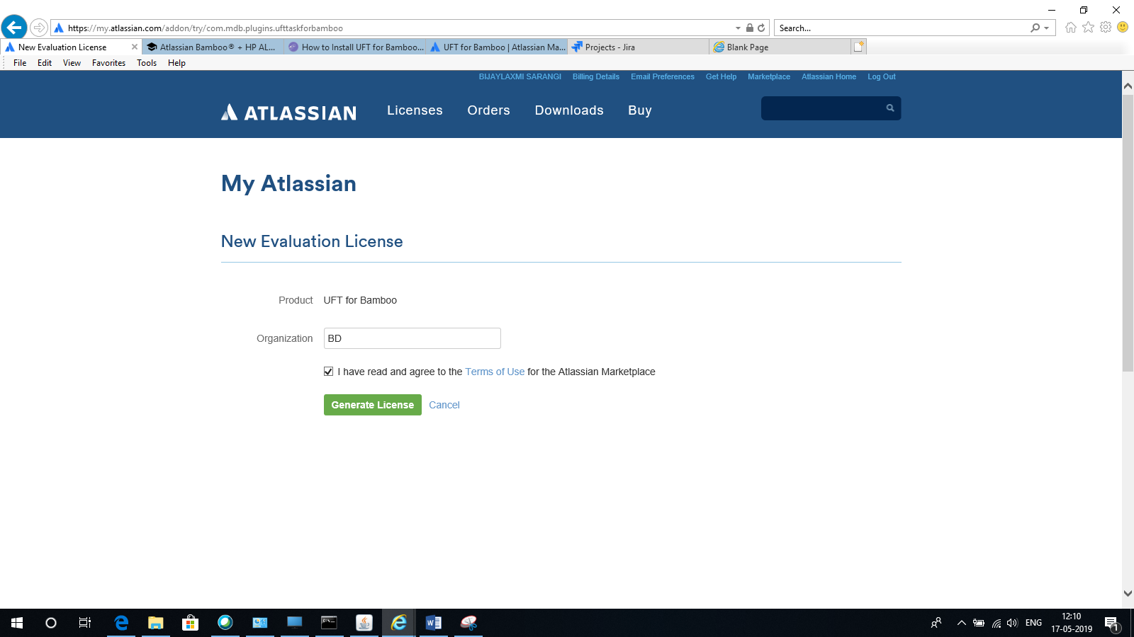

Generate License

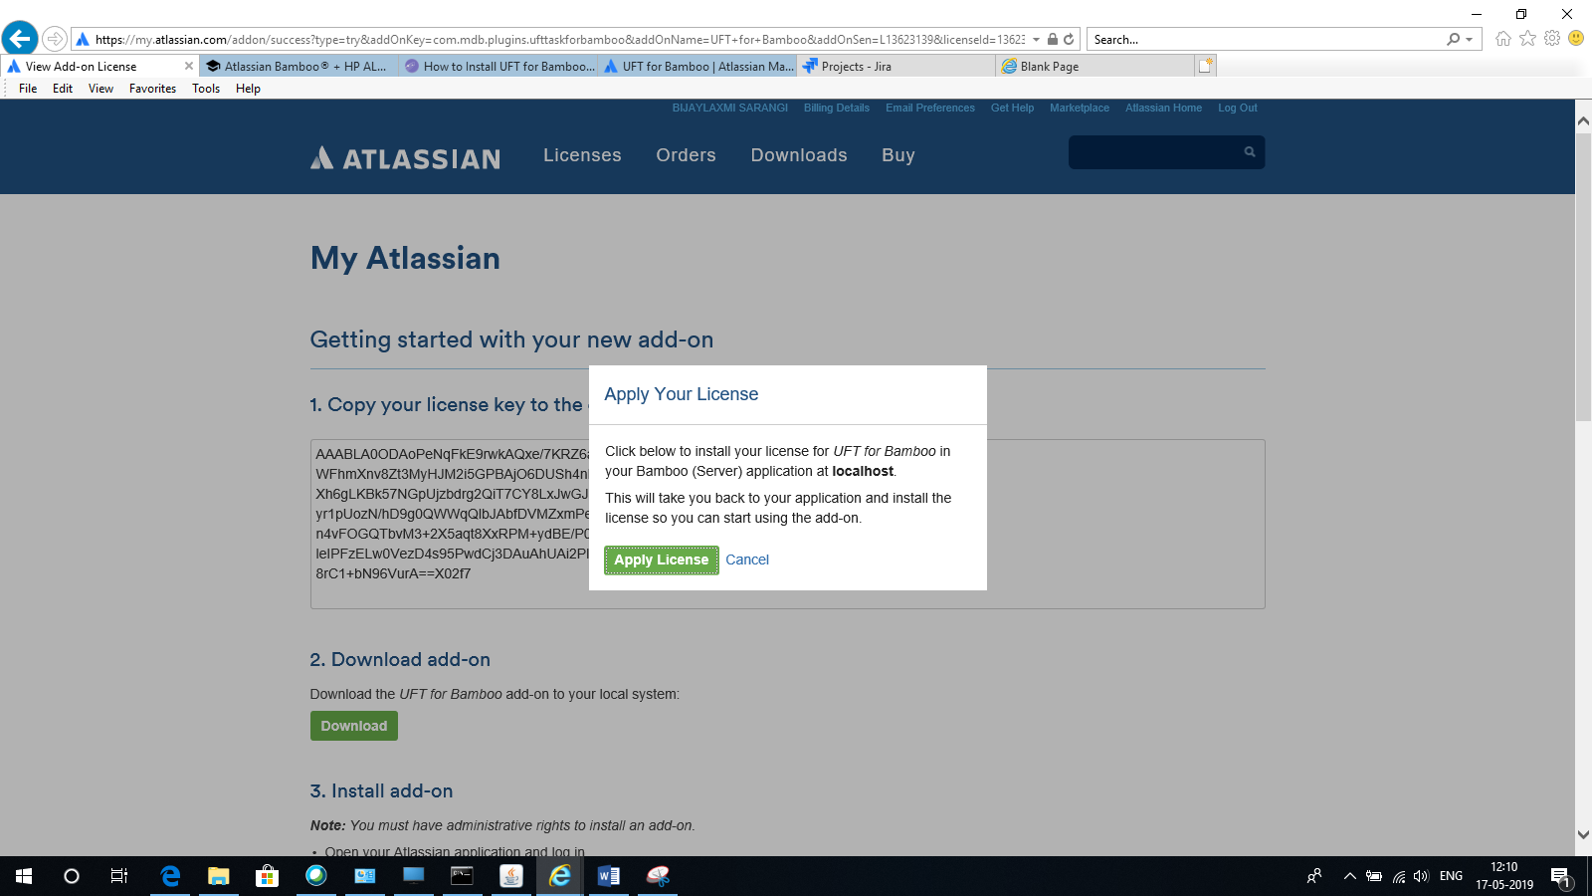

Apply License

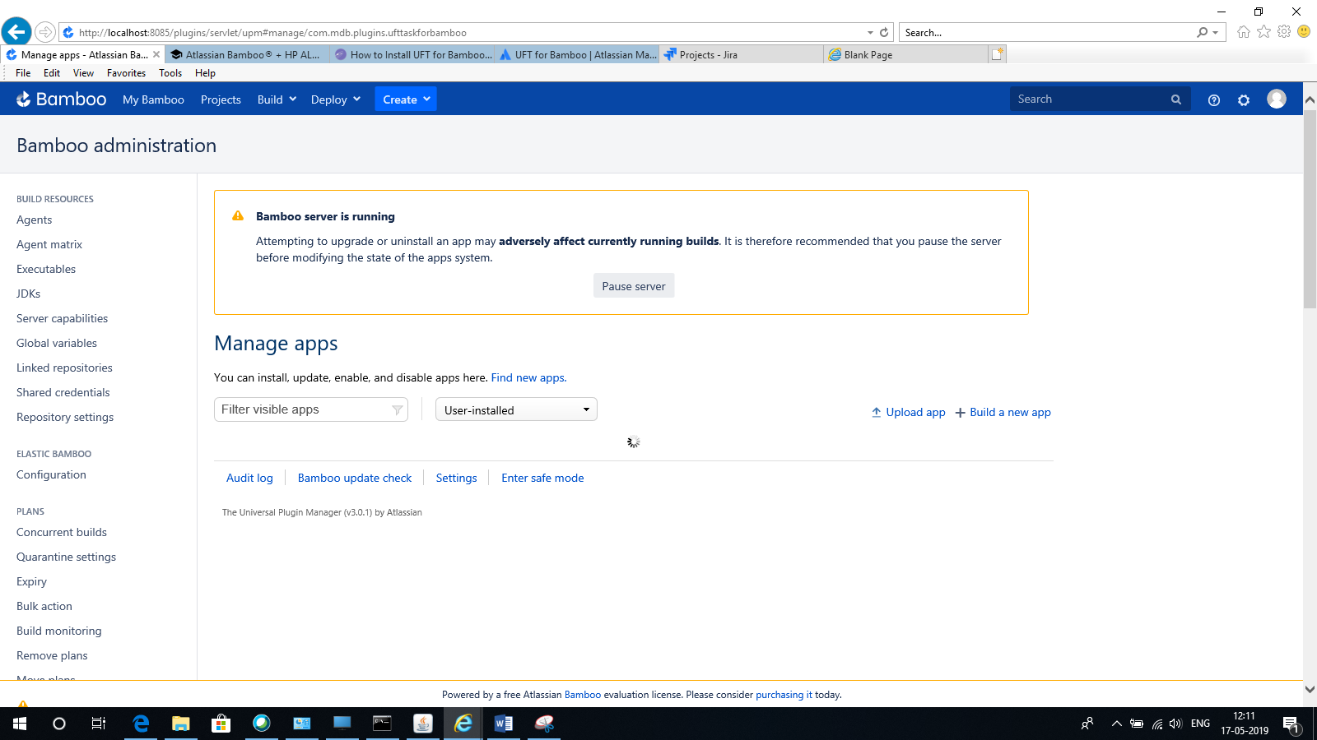

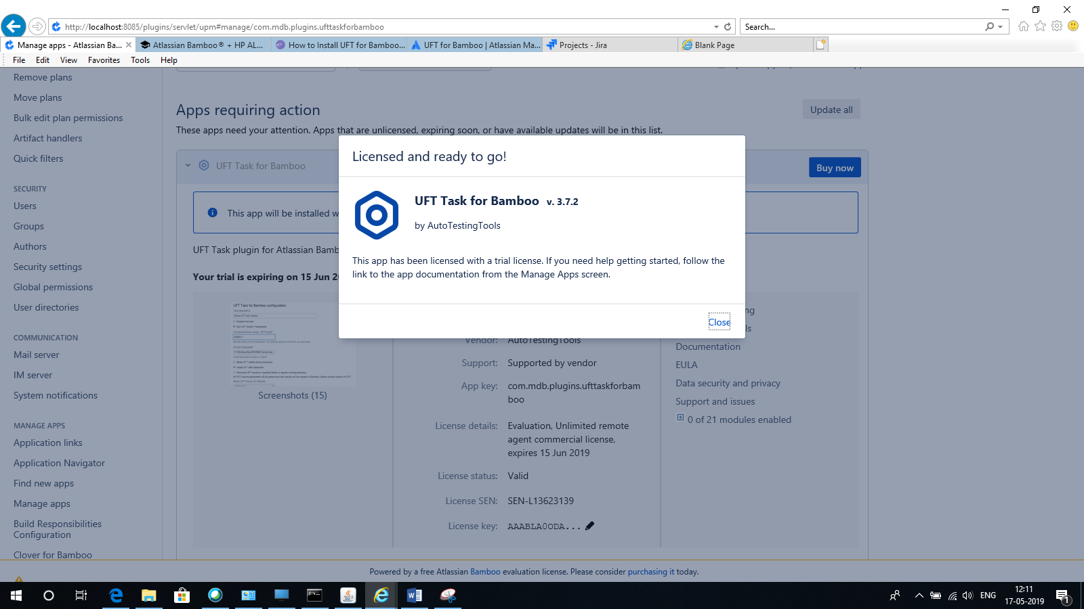

Close

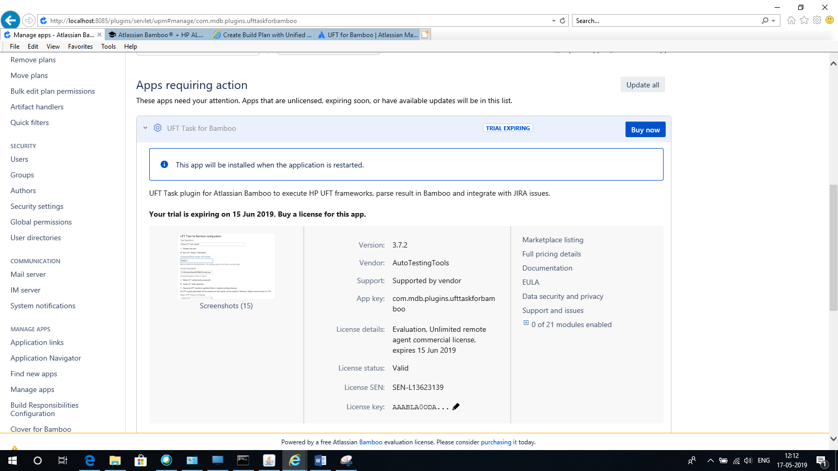

Create Build Plan:

