**Sprint One: User Access**

* Create roles and access as specified in the five roles below (I. Roles)
* Capture user information upon profile creation as specified below (II. User Capture Information)
* Show Profile information (II.) on Audit

1. **Roles**

**Anonymous / Consumer:**

* No Authentication
* Read-only access to application
* Have captcha to prevent spam

**Contributor:**

All rights of **consumer** plus:

* Authentication required (GAP)
* Capture user contact and institution information upon registering (GAP)
* Create User resource that is passed along for “History” so that someone can click on the resource to see the user affiliation and contact information (GAP)
* Can CRUD (create, read, update, delete) instance data only. Schema data is read-only (GAP)
* Default registration

**Editor**

All rights of **contributor** plus:

* Will have CRUD rights to editing Enumerated Types/Controlled Vocabulary
* Administered through Admin

**Reviewer**

All rights of **editor** plus:

* Will be able to Review triples and set review flags
* Administered through Admin

**User Admin**

All rights of **reviewer** plus:

* Manage users and roles (GAP)
* Add KB
* Can’t delete UDFR Ontology
* Be able to reset passwords for users (GAP) – done automatically?
* Be able to remove a user

1. **User Profile Information:**

For each registry user (regardless of role), capture the following profile attributes:

* Required
  + Account name
  + Full Name
  + E-mail
  + Institution affiliation
* Optional
  + Phone
  + Mailing Address
  + Expertise (foaf:interest ok?)

**Anonymous/Consumer**

No authentication. Read-only access to UDFR model.

1. Has ability to see that there is a UDFR Knowledge Base. Disable All options under “Knowledge Base” (from the UDFR graph button):

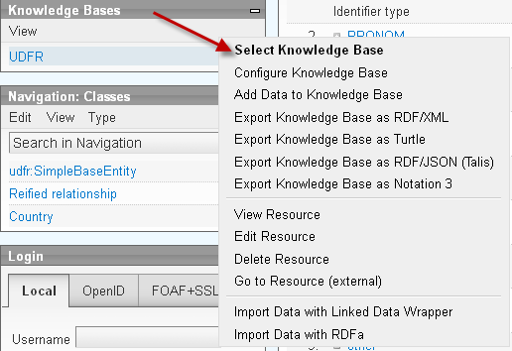

1. Also disable the View button:

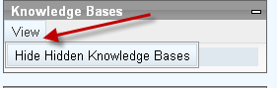

1. Disable All options under each class in the **Navigation: Classes** hierarchy with the exception of “List Instances (unless this can be done via clicking the class itself):

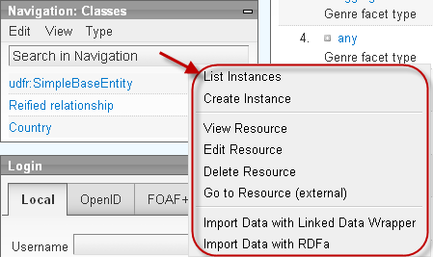

1. Disable option under **Edit: Add Resource here**

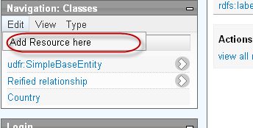

1. Disable **Community** and **Source** tabs (minimally disable “Community” as to prevent comment spam):

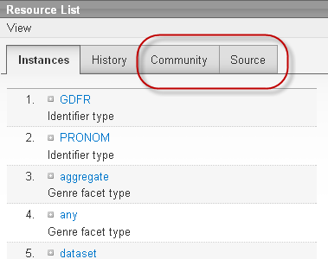

**Contributor**:

Authentication required. CRUD access to all instance data (with exception of Controlled Vocabularies)

1. Disable “Register New User” (low priority)

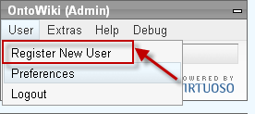

1. Disable “Select Language”?

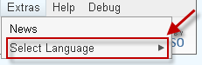

1. Redirect “Help” to our version of help:
   1. Documentation: TBD (where should we store it? On wiki?

(https://bitbucket.org/udfr/main/wiki/Home)

* 1. “Bug Report” :our Bitbucket bug tracking (<https://bitbucket.org/udfr/main/issues?status=new&status=open>)
  2. Version Info: TBD – bitbucket wiki?
  3. About: TBD – bigbucket wiki?

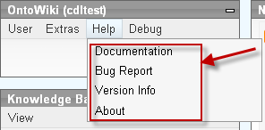

1. Disable all “Debug” features:

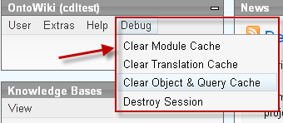

1. Disable:
   1. Configure/Add Data to…
   2. Delete KB
   3. Edit/Delete Resource
   4. *Go to Resource (external) –waiting decision.
   5. Import Data …

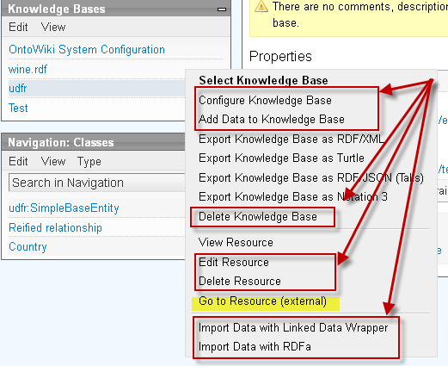

1. Disable “Edit…Add Resource here”

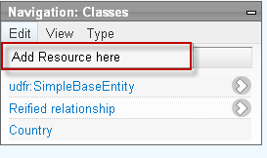

1. *Disable “View..Toggle Elements” option (low priority)

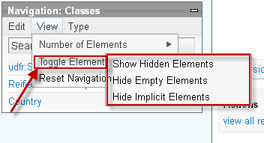

1. Under Navigation:Classes> Type, Disable:
   1. Edit/Delete Resource
   2. * Go to Resource (low priority) – pending decision
   3. Import Data…

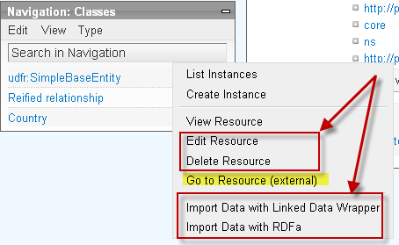

1. Under Navigation:Properties> Type, Disable:
   1. Delete Resource
   2. Goto Resource (low priority – pending decision)
   3. Import Data…
   4. **? Do we want to allow Edit Resource? – probably not.

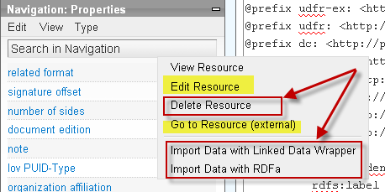

**Editor**:

All rights of **Contributor** plus the ability to edit Controlled Vocabularies

1. Under Navigation:Classes , **Allow** ability to edit resource for all subclasses of

Udfr:EnumeratedType (to be renamed “Controlled Vocabularies”)

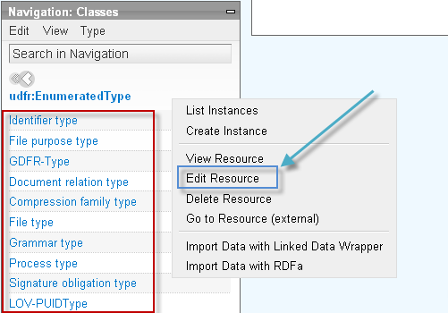

**Reviewer:**

All rights **Editor** plus the ability to mark “review” access to UDFR data

1. We can work out the details, but something that would show like this:

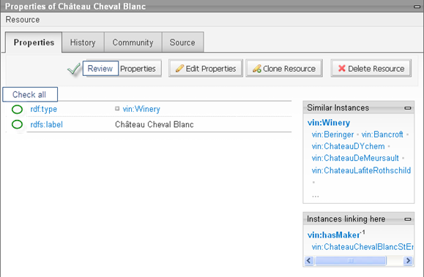

And results…

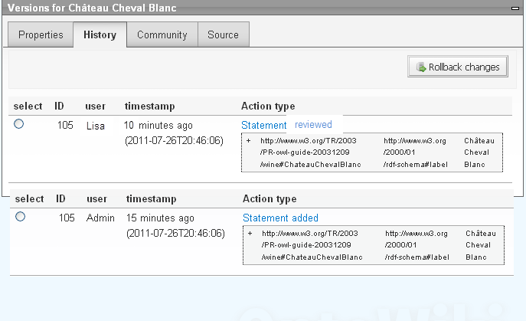

**Administrator:**

All rights of **Reviewer + Editor** and ability to edit schema and assign user rights.

Restrict Anonymous Login. Capture additional information upon Account Creation

Contributor role: restrict edit of class resources. Have captcha for self-service

Disable for all – delete KB resource. Disable for all(but admin) delete KB

Create user Profile for Audit History

Create Editor Role – allow edit of Controlled Vocabulary

Create Reviewer Role – allow approval flags – to be created per resource (instance) – but shown per statement (in Audit History window)