Use-Case Design Solution
Add/Remove user
1.Use case realization – Login
a.Sequence diagrams
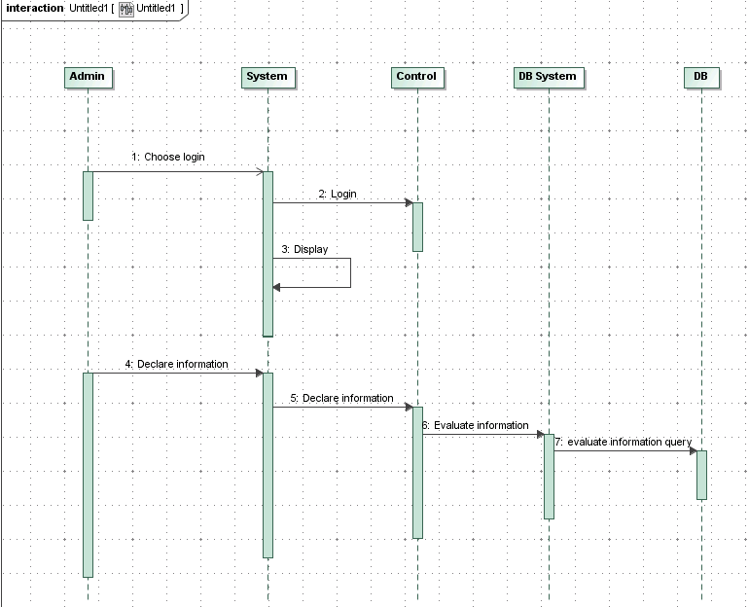

b. Collaboration diagram
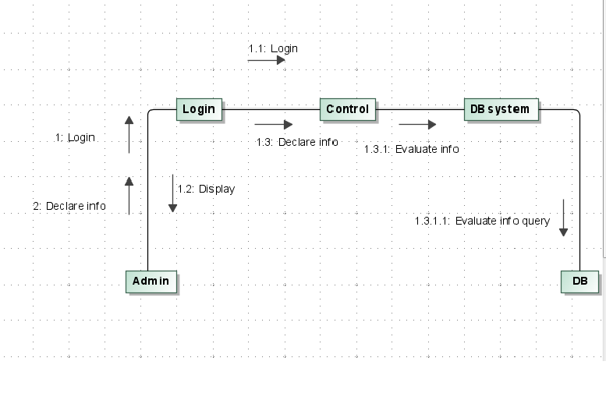

2. Use case realization :create
a.Sequence diagrams

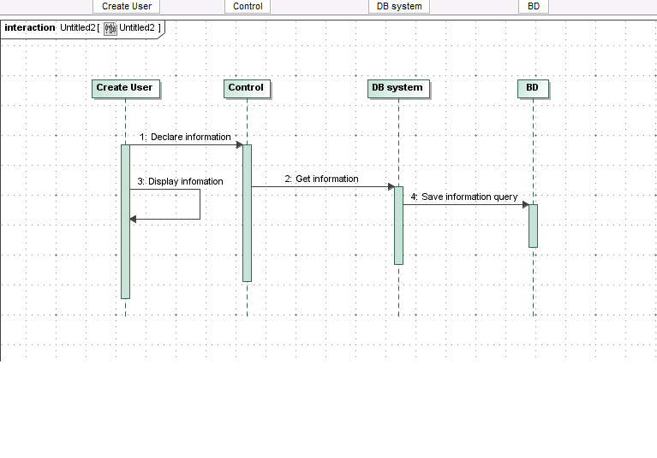

b. Collaboration diagram

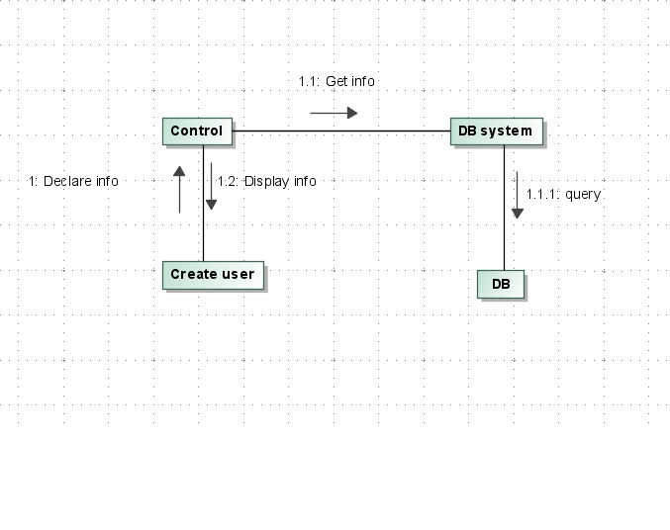

3.Use case realization : remove
a.Sequence diagrams
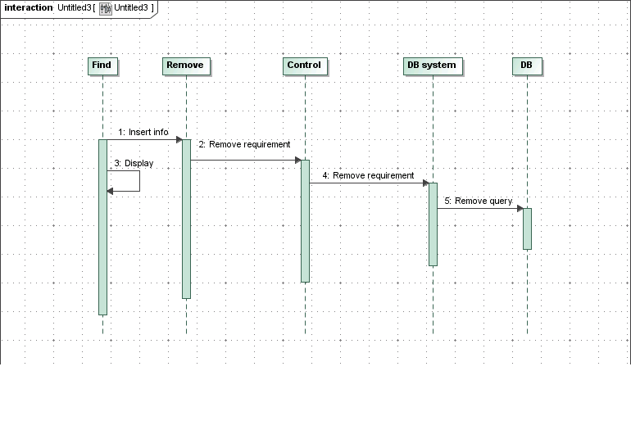 b. Collaboration diagram
